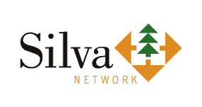
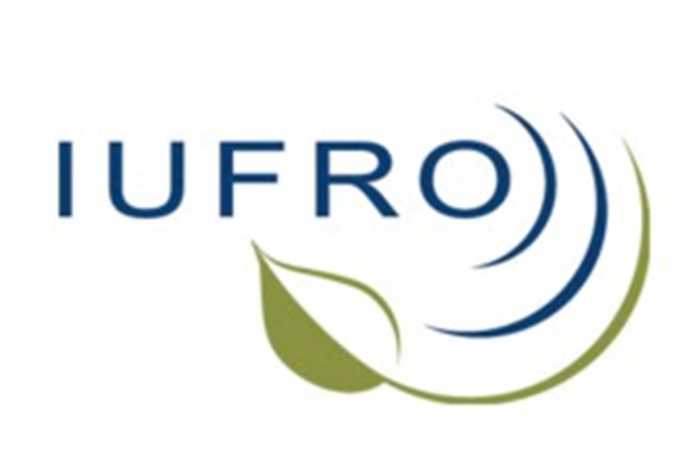
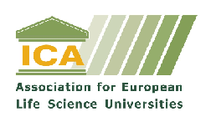

SILVA Network Conference
Should all Forestry Students learn the same?
Generalization versus Specialization

16. – 18. April, 2015

On behalf of the SILVA Network, the Department of Forest and Soil Sciences, BOKU - University of Natural Resources and Life Sciences, Vienna, Austria, will host a conference on Forestry Education.

Registration form

Please fill in and e-mail to siegfried.lewark@fobawi.uni-freiburg.de, copy to eva.lanz@boku.ac.at at your earliest convenience, but please not later than March20 7, 2015, if possible.

PERSONAL DETAILS

Surname: | First name:
Title (Prof./Dr./Mr./Mrs/Ms): | Organisation:
Email: | Address:
Postal Code: | City:
Country: | Phone/Fax:
Is your organisation SILVA-Network member? | Your position in your organisation:  (e.g. study advisor, international relations officer…)

Name: ________________________________

TRAVEL DETAILS

Means and place of your arrival
Flight____________________to____________________________
Train _____________________________
Other (what/where)__________________

Dates and times of arrival and departure:
Arrival in Vienna: _______________at___________o’clock
Departure from Vienna : _______________at___________o’clock

ACCOMMODATION

Accommodation that you booked: ________________________________

Please, if you did not yet make any booking, tell us when you did, so that we may contact you in Vienna.

FEES

Regular participation fee is 150 € (special fees for students), which will include: 3 lunches, the conference dinner, tea/coffee breaks during the conference, and the excursion.

Fees must be paid in cash upon arrival.

