
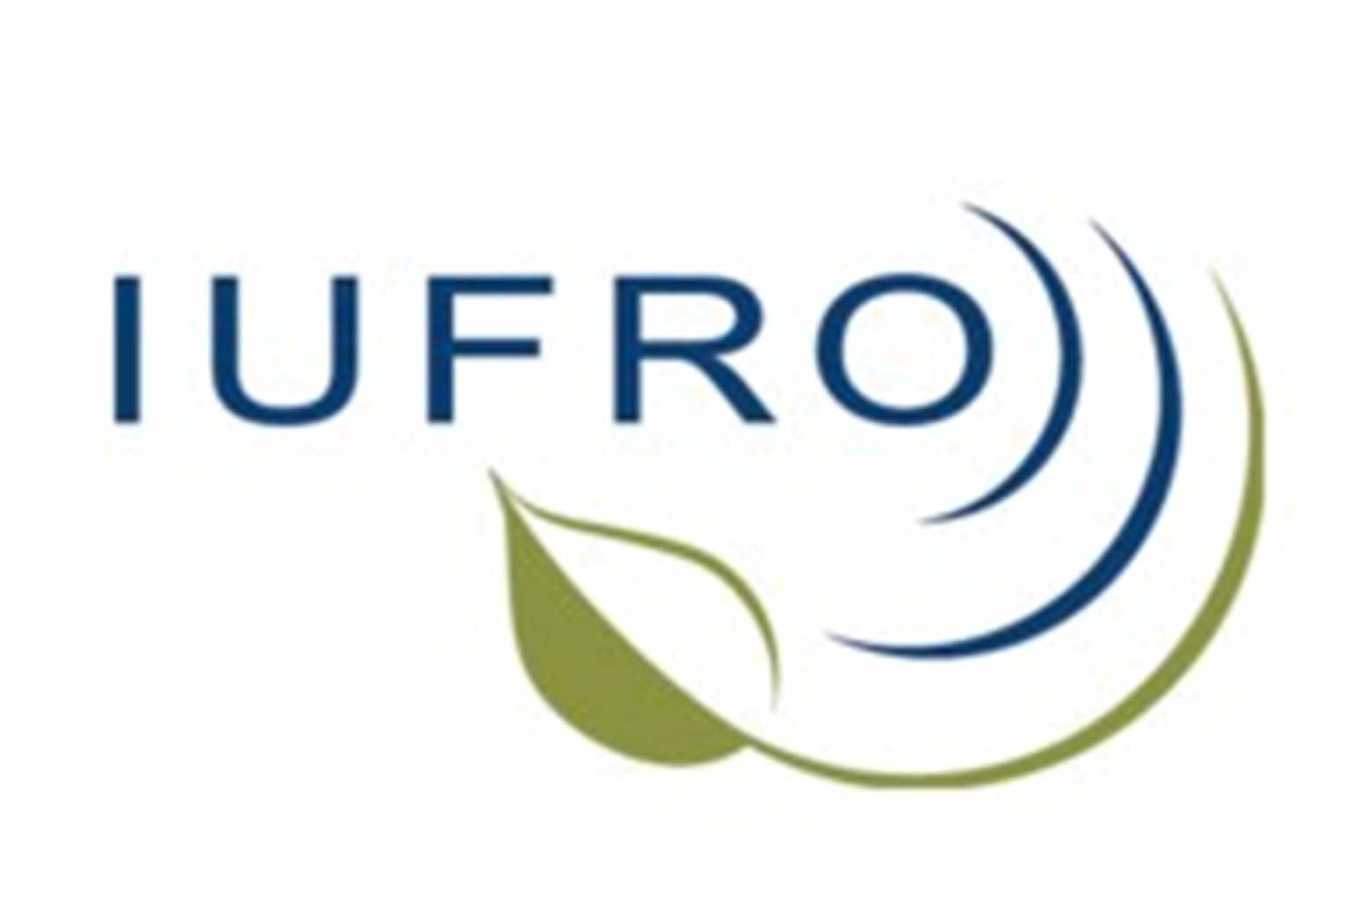  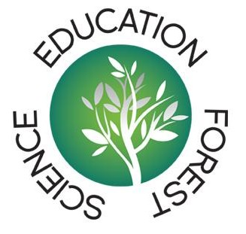 | 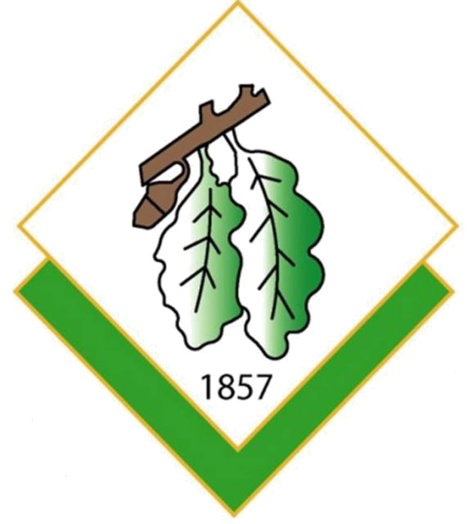  ISTANBUL UNIVERSITY  FACULTY OF FORESTRY  TR- 34473 Bahçeköy  Istanbul TURKEY  Tel. +90 212 226 11 11  Fax +90 212 226 11 13  e-mail: yserengil@yahoo.com  www.orman.istanbul.edu.tr

Annual conference

November 1st till 3rd 2013

From teaching to learning –
when will we take it seriously in forest sciences education?

On behalf of the SILVA Network, the Faculty of Forestry, Istanbul University, Turkey, will host a conference on Forestry Education. The conference is co-organised by the IUFRO Task Force “Education in Forest Science” as an EFS education conference.

Registration form

Please fill in and e-mail to siegfried.lewark@fobawi.uni-freiburg.de, copy to yserengil@yahoo.com at your earliest convenience, but please not later than October 7, 2013, if possible.

PERSONAL DETAILS

Surname: | First name:
Title (Prof./Dr./Mr./Mrs/ms): | Organisation:
Email: | Address:
Postal Code: | City:
Country: | Phone/Fax:
Is your organisation SILVA-Network member: | Your position in your organisation:  (e.g. study advisor, international relations officer…)

TRAVEL DETAILS

Date and time of arrival and departure:
Flight__________________to______________________________
Arrival in Istanbul: on_______________at________o’clock
Departure from Istanbul: on_______________at________o’clock

I will participate in the field trip on Nov 1st: yes no

ACCOMMODATION

Participants have to make their accommodation arrangements themselves. Hotels around Beyazit, district of Istanbul University main campus, are suggested. Bus transport will be organised from Istanbul University main campus in Beyazit (where most hotels and sightseeing are located) to the Forestry Faculty campus, around one hour driving time.

Accommodation which you booked:_______________________

Please, if you did not yet make any booking, tell us when you did, so that we may contact you in Istanbul.

A limited number of rooms will be available at the Emniyet guesthouse next to the Bosporus (www.istanbulpmem.pol.tr) and closer to the venue (50 Euros+4 Euros breakfast). Bus transport will be organised. Please contact Yusuf Serengil for your requests directly. Rooms will be given according to the sequence of request.

FEES

Regular participation fee is 140 € (special fees for students), which will include lunches, dinners, tea/coffee breaks during the conference, also the field trip.
Fees must be paid in cash upon arrival.

SPECIAL REMARKS

Please add here e.g. any dietary requirements if applicable (for example vegetarian, no fish, no meat, no pork etc.) or any other special requirements.

PROGRAMME

The programme will comprise two days of indoor conference (Nov 2, 9.00 h to Nov 3, 16.00 h) preceded by a field trip day (November 1) together with Conference of Deans and Directors of European Forestry Faculties and Schools (ConDDEFFS), which is planning its annual conference prior to the SILVA Network conference. The field trip will go to Kocaeli province some 2 hours away from Istanbul. It is going to be a full day technical excursion

Information on the actual programme will be found on the SILVA Network homepage.

We look forward to meet you in Istanbul!

