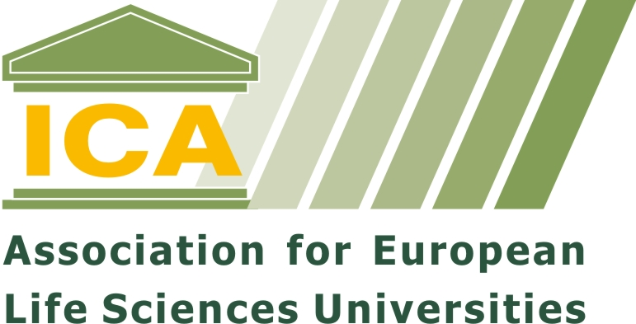
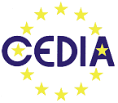


Registration Form

Registration deadline 1 May 2009

Models for successful collaboration and partnerships of purpose between universities, businesses and NGOs

- in education, research and consultancy

10 to 13 June 2009, to be held at

Leuven Institute for Ireland in Europe, Leuven (BE)

Please complete this form and email to Ida Krogager imkr@life.ku.dk

Outline timetable
Wednesday  June 10 | 16.00 ICA Gneral Assembly  18.30 Conference Reception
Thursday  June 11 | 9.00 Conference opening  18.30 Reception City of Leuven, followed by dinner
Friday  June 12 | 9.00 Conference continues  19.30 Conference dinner
Saturday  June 13 | Depart  CEDIA Annual Meeting

Registration:
Please complete the form below to register for the Conference and make a payment to the ICA bank account to confirm your registration.

Hotel Bookings:
It is your repsonsibility to book your hotel accommodation. Information regarding hotels reserved for the Conference is detailed in the Conference flyer and programme.

Registration form for ICA-CEDIA-KULeuven Conference June 2009

Registration deadline 1 May 2009

Title:
First name:
Family name:
Name Institution:
Function:
Address
Postcode
City
Country
Email address:
Tel no:
Fax no:

Special diet? :

Extra information ? :

I am a delegate from an ICA member institutions, ICA Standing Committees and CEDIA members
Yes / No please cross out

Arrival and departure
Please tick
I will arrive
Wednesday 10 June
Thursday 11 June
Friday 12 June
I will depart
Thursday 11 June
Friday 12 June
Saturday 13 June

Registration fee
The Registration fee covers the Reception on Wednesday, the cost of coffee breaks, lunch and dinner on Thursday and the cost of coffee breaks and lunch on Friday. The Conference dinner on Friday night is charged separately.

 |  | € | Please tick
Registration fee | For delegates from ICA member institutions, ICA Standing Committees and CEDIA members | 295
 | For delegates from other institutions | 345
 | Student | 140
Conference dinner Friday 12 June |  | 50
Total Regsitration fee

Cancellation policy
If you wish to cancel your registration full refund of the Registration Fee will be made if the ICA Secretariat is notified and has acknowledged cancellation by 15 May. After the 15 May the registration fee will not be refunded.

Bank Payment
Please transfer registration fee to the following account:
Bank: KBC
Address of Bank: Brugsesteenweg 513, B-9030 Mariakerke (Belgium)
Swift code: KREDBEBB

IBAN: BE21 7370 1215 0103
Beneficiary: ICA
Reference: ICA Conference 2009 <your name>

All bank charges are the responsibility of the payee. Payment by cheque, credit card or cash is not accepted. If this presents a partiular problem please conatct Ida Krogager, ICA Secretariat.

Please email your regsitration to:
Ida Marie Krogager
ICA Secretary
University of Copenhagen
Faculty of Life Sciences
Bülowsvej 17
DK-1870 Frederiksberg C

Phone: +45 35 33 23 74
Email: imkr@life.ku.dk

