FOREST SCIENCE EDUCATION:

Self-study and activation of the learner

Proceedings of the SILVA Network Conference, held at the Institute of Forestry and Rural Engineering of the

Estonian University of Life Sciences, Tartu, Estonia,

September 21st -23rd, 2016



SILVA Publications 14

2017

Editors

P. Schmidt, S. Lewark, V. Reisner

This book is published at the

University of Freiburg

Freiburg im Breisgau

Germany

Keywords: forestry university education, guided self-study, curricula, thesis ring, self-assessment, students’ recruitment, studying abroad.

ISBN 978-00-058537-1

# PREFACE I

The SILVA Network aims to improve forestry and forest science education through facilitating discussions between teaching institutions, teachers and learners in these fields. The SILVA Network uses mainly two means to reach its aim: annual conferences and the proceedings based on them.

A relatively small number of members of the SILVA Network participated in this meeting in Tartu, Estonia September 2016. This did neither diminish the quality of the presentation nor the intensity of the discussions. We, the editors, are sure every participant learned aspects, which are useful when active in teaching and organising teaching at home.

The visit to the Järvselja Forest Experimental Centre though the Estonian countryside gave insight into the problems met by Estonian foresters and the way they cope with it.

Thanks and tribute to the Institute of Forestry and Rural Engineering of the Estonian University of Life Sciences and its staff members for hosting this meeting and for organising the trip to the experimental forest.

Thanks also to Martin Ziesak, Francesco Pirotti and Gerhard Müller-Starck, who, in cooperation with the three editors, reviewed the papers presented here. The third party we would like to thank are the authors of these papers. Without these speakers/authors and the reviewers these proceedings would not exist.

The editors

**PREFACE II**

The SILVA Network organized from September 21st till September 23rd its annual conference 2016, entitled ‘Self-Study and Activation of the Learner’ in Tartu, Estonia. Local organizer was the Estonian University of Life Sciences, Institute of Forestry and Rural Engineering.

The conference focused on how the student would be an active participant in supported learning, which would be the necessary tools and teaching materials for this purpose. The conference was opened by three representatives of the host university and the SILVA-Network:

* Dr. Paavo Kaimre, Vice-Rector of the Estonian University of Life Sciences, host of the meeting, welcomed the participants;
* Prof. Dr. Hardi Tullus welcomed participants on behalf of the host university forestry departments;
* Prof. Dr. M. Ziesak, President of SILVA Network, formally opened the conference.

Various topics were addressed at the conference, for example an overview about the forestry related students background was given (Meelis Teder, Estonian University of Life Sciences) and the expectations of practitioners for learning and forestry education in general (Sarah Pohlschneider, Iverness College, United Kingdom). At the same time, there were very practical examples of how to support and direct self-education (Neeltje van Hulten, Wageningen University), about the tools supporting self-study (Jiří Remeš, Czech University of Life Sciences Prague), and what tasks have been tried to make students more active during learning process (Martin Ziesak, HAFL, Switzerland).

As usual, a representative of IUFRO (Mika Rekola) was also present, who highlighted the links between the topics of the SILVA Network conference and the goals of the IUFRO work-groups.

During the conference an interactive workshop “Challenges and possible solutions in self-study implementation in higher forestry education” and a field trip to the Järvselja Forest Experimental Center took place. In Järvselja vice-forester Priit Kask made an introductory presentation and then the participants visited a shelter wood method experimental area, plantation forestry examples, an air humidity manipulation area and the experimental plot of oak management in boreal forests.

The Institute of Forestry and Rural Engineering of the Estonian University of Life Sciences felt honoured to organise this conference.

Vaike Reisner

Hardi Tullus

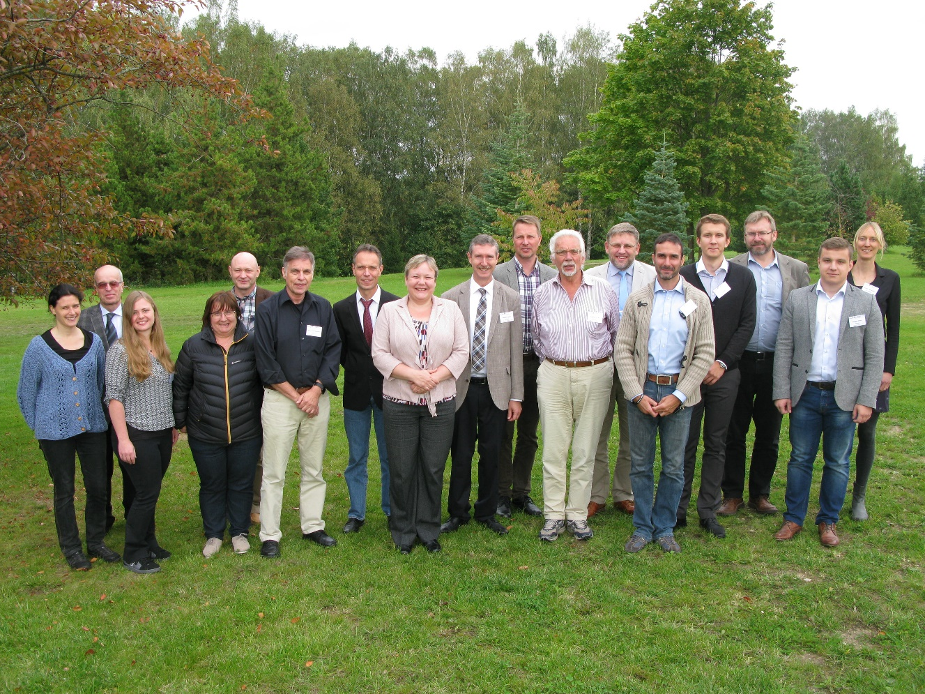

Participants of the annual conference of the SILVA Network in Tartu, Estonia, in September 2016.

**CONTENTS**

|  |  |  |
| --- | --- | --- |
| **Summary** | Pieter Schmidt | 1 |
| **Introduction** | Martin Ziesak | 5 |
| **Implementation of guided self-study in forestry curricula, examples from HAFL, Switzerland** | Martin Ziesak and Christian Rosset | 7 |
| **What will activate the forest science student to self-study: Perspectives from southern Europe forestry students** | Tatenda Mapeto and Alice Cossatti | 11 |
| **Wageningen educational ecosystem: blending campus activities** | Neeltje van Hulten | 20 |
| **Education at the Faculty of Forestry and Wood Sciences, Czech University of Life Sciences, Prague – current situation and innovative strategy** | Jiří Remeš | 28 |
| **Understanding forestry stakeholders’ and practitioners’ experiences and perspectives on learning and education for future forestry** | Sarah Pohlschneider and Philomena de Lima | 34 |
| **Estonian forestry students’ pre-study background and their interest in exchange studies abroad** | Meelis Teder and Vaike Reisner | 41 |
| **The joint IUFRO-IFSA task force on forest education** | Mika Rekola, Magdalena Lackner, Janice Burns and Sandra Rodríguez-Pineros | 49 |
| **Estonian forestry students’ association** | Kristjan Sepp | 55 |
| **Concluding remarks** | Martin Ziesak | 57 |
| **SILVA Network communique 2016** |  | 59 |
| **Participants** |  | 60 |
| **Proceedings of the SILVA Network conferences** |  | 63 |

**SUMMARY**

**FOREST SCIENCE EDUCATION: SELF-STUDY AND ACTIVATION OF THE LEARNER**

**PIETER SCHMIDT**

It was a small but enlightening meeting in Tartu, Estonia, discussing possibilities to activate learners by self-study. Three contributions, one by IFSA students, concerned this subject. The other contributions discussed the innovative strategy of an old university, the motivation of students to integrate a study abroad in their curriculum and the developing activities of the IUFRO-IFSA taskforce on forest education. All are relevant subjects for the SILVA Network community. At the end, Estonian students presented their students’ society. All in all the contributions represent insightful reading material for learners and teachers of forest science education.

**Introduction**

In his introduction, Martin Ziesak stated that the subject chosen for this conference ´Self-study and the activation of the learner´ typically fits in scoop of subjects discussed since the first large SILVA Network conference in 1997. It will be interesting to see what challenges, options and what risks may be seen, when it comes to the application of self-study in forestry teaching activities and how it may help to foster the activation of the learner. He expects, that some ideas and stimuli can be extracted from the contributions presented below.

**Guided self-study**

Guided self-study is already for some years standard practice at the School of Agricultural, Forest and Food Sciences (HAFL), at the Bern University of Applied Sciences (BFH). Martin Ziesak and Christian Rosset describe its implementation, starting with the characteristics of guided self-study. They describe four cases of guided self-study at their university, the subject of each is a very well recognisable item in forest management: Cost-benefit analysis, forest operations, tree height measurements and silvicultural regeneration planning. They conclude that the key factors in a successful implementation are based on several rules and support factors. Included in these are for instance precise guiding and supporting mechanisms for the students in their tasks, but also accompanying support to the lecturers (for instance a course “How to guide self-study”) by the university. Moreover, they conclude that through this activation and thus motivation of students the content uptake may be even better than with for students less stimulating teaching formats.

In recent years, SILVA meeting outcomes have indicated a clear trend of forestry education foci shifting towards the learner. IFSA forestry students Tatenda Mapeto and Alice Cossatti state that in the early 2000s, these conferences were mainly attended by educational practitioners. However in recent years, with the global movement towards stakeholder inclusion, the SILVA Network conferences have opened up to student input, particularly through the International Forestry Students Association (IFSA). In support of this student inclusive approach IFSA designed a dialogue workshop in line with the SILVA Network conference meeting theme for 2016, which is discussed here. The dialogue was developed by IFSA’s Forestry Education Commission and was put into action during the IFSA Southern Europe Regional meeting in Italy. The dialogue presented participants with brief analyses of SILVA publications, summaries of outcomes from the past five years of SILVA Network meetings and an indication on the evolvement of the actual theme. This was done in collaboration with students who have participated at SILVA Network meetings before. The workshop sought to acquire forestry student perspectives on: 1) What do the students define as self-study? 2) Do they think that self-study is important in their education? 3) Do the different institutions where the students come from support self-study and if so, besides massive open online courses (MOOCs) what other platforms and technologies are there to support self-study? 4 What do the students think can be done to encourage self-study and what can they do to activate themselves and their teachers for self-study? A total of 55 students participated in the dialogue. Interesting outcomes from the dialogue include a strong resonance amongst the students 1) That passion of students is a key ingredient in stimulating self-study; 2) That universities are not providing platforms encouraging self-study; 3) That current pedagogies do not have space for or affection to self-study. Participants however provide a range of tools and techniques which can be employed by tertiary institutions in order to activate self-study.

Neeltje van Hulten describes the current changes in education at Wageningen University towards an educational ecosystem with a blend of campus and online facilities, and cooperation with other institutes, as well as the consequences for students and the study programme Forest and Nature Conservation.

Two examples of educational activities, thesis rings and a self-assessment both for BSc and MSc students are discussed to show implications of a changing educational system.

The self-assessment makes students more aware of their skills and desired career paths. One test indicates which of twelve career motives are important for a student, a second one indicates the qualities of a student on eighteen different skills. There is a follow-up online or in small groups, supervised by a teacher. The assignments help students to discover the link between their career motives, skills, the choices they make in their study programme and their future careers.

Most students and teachers are positive about the thesis rings in which students review each other’s progress. They work in small groups (7-10 students) with an academic staff member as chairman. Each week parts of two theses of participating students are discussed. Of course the roles of both teachers and students are different from the traditional ones.

Wageningen University is in a permanent progress of improving, adapting and organizing its education, and therefor implications for the future are difficult to assess, but online facilities will become more important. But the extent in which online learning will become part of regular BSc and MSc programmes is not clearly defined yet.

**Improving students’ recruitment and curricula**

The current situation and the new innovative educational strategy at the Faculty of Forestry and Wood Sciences (FFWS), Czech University of Life Sciences Prague (CULS), is presented by Jiří Remeš. The FFWS is a modern, dynamically developing educational institution with a long tradition and a vision on the future. The numbers of students in Bachelor's and Master's programmes have stabilized now at about 1,750 students after a low entrance rate around 2010, due to low birth rates during the last two decennia. The additional problem of high failure rates was tackled by identifying its cause. The new educational strategy of FFWS includes 1) Concentrating the numbers of students admitted to students with the best competences; 2) Structuring of the study so that the composition of the study subjects would correspond with the graduates’ profiles and the specificity of individual curricula; 3) Increasing of the motivation and interest of students and making learning more attractive; 4) Gradually improving study conditions and optimising the process of teaching.

The new strategy has resulted in new modern classrooms as well as teaching laboratories. The study programmes are innovated in line with the needs and requirements both of forestry and wood industry and by implementation of modern teaching methods (including e-learning).

According to Sarah Pohlschneider and Philomena de Lima forestry world-wide makes a fundamental contribution to environmental, social, wellbeing and economic objectives but will be subject to uncertainty and complex challenges. More than ever educational institutions offering forestry courses are urged to educate future forestry professionals who have the capacity to address the complex roles that forestry is increasingly required to perform. The forestry sector in Britain appears to be experiencing a rising demand for a skilled workforce while students’ interest in pursuing forestry careers declines. Thus, improving recruitment and providing future practitioners with relevant education and skills are a major concern. Much of the research on the labour requirements of forestry has tended to focus on the supply side (e.g. forest industry and universities) encompassing competing views on how forestry is conceptualised and understood. Providing an alternative approach, this on-going qualitative study elucidates forestry professionals’ experiences and perspectives regarding their conceptualisation of forestry, career and skills required for the future of forestry in Britain. Drawing on in-depth interviews and a very preliminary analysis of the data are identified to provide the basis to conceptualise and contextualise interviewees’ experiences in a broader education discourse. Understanding practitioners’ views is a step towards a more holistic concept of forestry fit for the 21st century.

**Studying and students**

Internationalization is, according to Meelis Teder and Vaike Reisner, one of the hot topics in higher education. Universities are preparing full programmes or at least some special courses taught in English targeted to exchange students. The availability of courses in English is also an important assessment criterion for higher education accreditation, at least in Estonia. Despite these efforts made by universities, the Estonian forestry students, at least at the beginning of their studies, are not interested in or motivated for attending exchange study programmes in foreign universities. The majority of forestry students are, in contrast to natural resource management students, from rural areas or they consider themselves as rural persons. They are mainly studying in their first field of interest and are more practical oriented. These students do not plan far ahead shortly after enrolment. Only a small number are interested in an academic career, where a study abroad is an asset, many of them are more interested in the local conditions determining the forestry.

The International Union of Forest Research Organizations (IUFRO) and the International Forestry Students’ Association (IFSA) are running 2015-2017 a Joint IUFRO-IFSA Task Force (JTF) on Forest Education. According to Mika Rekola, Magdalena Lackner, Janice Burns and Sandra Rodríguez-Pineros the aim of the JTF is not only strengthening the education on forests and practices, but also highlighting ways to make the sector attractive for young people. The aim of JTF is to bring together students, educators and other stakeholders to encourage international discussions on forest education and to identify the gaps and challenges in the educational sector. It also aims to enhance forestry students’ mobility and education opportunities.

The work of the JTF is divided into four working packages (WP): 1) Global Outlook on forest education (GOFE); 2) Higher forest education interactive tool; 3) Trainings for forestry students; and 4) Encouragement of students' involvement in IUFRO events and counterbalance of extracurricular students’ activities. On each of them, work done and progress made are reported, indicating the relevance of collaboration by research-student organisations.

Kristjan Sepp presents the history of the Estonian Forestry Students’ Association, discussing its founding and its activities. Its main aim may be establishing contacts between the forester-to-be and the forester in being, between students and practising foresters.

**Concluding remarks**

In his concluding remarks, Martin Ziesak recapitulated the main questions as raised during the discussions after each presentation and during the general discussion at the end. There proved to be a certain consensus among the participants: Yes, we do need guided self-study during forestry education at universities. And, an active and directed university policy should bring about a change in the mind sets of both learners and teachers.

**INTRODUCTION**

**MARTIN ZIESAK**

In the long list of topics for the SILVA Network annual conferences many times pedagogical themes were highlighted. For instance the 2013 meeting in Istanbul covered the question “From teaching to learning – When will we take it seriously in forest sciences education?”, where several contributions took up didactical themes (see Schmidt and Lewark, 2015). But also back in the 1997 SILVA Network conference in Wageningen (“New requirements for university education in forestry”) educational and pedagogical questions were touched intensively (see Schmidt *et al*., 1998). For the 2016 annual conference again a topic was chosen, which centres very much on pedagogics: “Self-study and activation of the learner”.

The “learning instrument” of self-study – with its typically three separated sub forms of accompanied self-study, individual self-study and free self-study – is not really new. However, it may be interesting to notice that in particular in academic teacher education this learning vehicle is considered quite intensively (see for instance Vanassche and Kelchtermans, 2015 or Loughran *et al*., 2004).

While the term “self-study” seems self-explaining, it still may be good to have a definition first. A good explanation is given by Mishler (1990), describing self-study with the following characteristics: it is self-initiated and focused; it is improvement-aimed; it is interactive; it includes multiple, mainly qualitative, methods; and, it defines validity as a validation process based in trustworthiness (Mishler, 1990).

With the specific challenges in forestry education it is interesting to see what risks and options may be seen, when it comes to the application of self-study in forestry teaching activities and how it may help to foster the activation of the learner. It is the hope, that some ideas and stimuli can be extracted from the contributions presented to the conference.

**References**

Loughran, J.J., Hamilton, M.L., LaBoskey, V.K. and Russell, T., (Eds.), 2004: International Handbook of Self-Study of Teaching and Teacher Education Practices. Dordrecht: Springer Netherlands.

Mishler, E., 1990: Validation in inquiry-guided research: The role of exemplars in narrative studies. Harvard Educational Review, 60(4), 415–442.

Vanassche, E. and Kelchtermans, G., 2015: The state of the art in Self-Study of Teacher Education Practices: a systematic literature review. In: Journal of Curriculum Studies 47 (4), 508–528.

Schmidt, P., Huss, J., Lewark, S., Pettenella, D. and Saastamoinen, O., (Eds.) 1998: New requirements for university education in forestry. DEMETER SERIES 1

Schmidt, P. and Lewark, S., (Eds.): 2015: From teaching to learning – When will we take it seriously in forest sciences education? SILVA Network Publications 11

**IMPLEMENTATION OF GUIDED SELF-STUDY IN FORESTRY CURRICULA, EXAMPLES FROM HAFL, SWITZERLAND**

**MARTIN ZIESAK AND CHRISTIAN ROSSET**

*„Nicht das Wissen kräftigt, sondern das Verstehen;*

*nicht die Aufsammlung im Gedächtnis,*

*sondern das Verarbeiten im Verstande;*

*nicht das Aufspeichern der Massen, sondern das Assimilieren;*

*nicht das Betrachten, sondern das Suchen;*

*nicht das Glauben, sondern das Prüfen;*

*nicht das Lernen, sondern das Üben;*

*nicht das Fertige, sondern das Zubereiten;*

*nicht das Vorkauen, sondern das Machen.“*

*[Not knowledge strengthens, but understanding,*

*not collecting but processing in the brain,*

*not hording of quantities, but assimilation,*

*not viewing but search,*

*not contemplating but verifying,*

*not learning but exercise,*

*not the fixed but the preparation,*

*not predigestion, but the doing.]*

*Adolph Diesterweg, 1836*

**Abstract**

The idea to activate students by accompanied self-study is described and its realisation in the forestry study programme of the School of Agricultural, Forest and Food Sciences at the Bern University of Applied Sciences. The key factors of a successful implementation are based on several rules and support factors. Included in these are for instance precise guiding and supporting mechanisms for the students in their tasks, but also accompanying support to the lecturers by the university.

Keywords: Activation of the learner, accompanied self-study, forestry.

**Introduction**

For several years at the School of Agricultural, Forest and Food Sciences (HAFL, Hochschule für Agrar-, Forst- und Lebensmittelwissenschaften), at the Bern University of Applied Sciences (BFH, Berner Fachhochschule) guided self-study, is used quite successfully in the activation of the student, the learner.

In principle it is easily possible to separate the less activating from the more activating teaching or course types, although there may be a certain gradient in their form of activation (see e.g. the elements as described in Bales, 1995). While the classic ex-cathedra lecture is a typical form of less activating, a group discussion is a much more activating teaching form.

In an initial approach to course types a comparison of typical characteristics of contact studies, like lectures, seminars or exercise courses, versus guided self-studies and free self-studies may help to understand the essence of guided self-study (see Table 1). As an important characteristic the role of the respective lecturer may be seen as follows: while in contact studies his presence is indispensable, in guided self-study this is not strictly required and in free self-study it isn’t needed at all. Furthermore, for a successful implementation, the high importance of an assignment in guided self-study must be pointed out.

|  |  |  |  |
| --- | --- | --- | --- |
|  | **Contact study** | **Guided self-study** | **Free self-study** |
| **Place** | Determined | May be free | Definitely free |
| **Time** | Strictly bound to a class schedule | Mostly, free, individual choice; outside lecturing time | Free, individual choice |
| **Presence of lecturer** | Yes, indispensable | Partially to no | No |
| **Support of lecturer** | Yes  (like e.g. answering of questions, guiding a discussion) | Yes | Not, may be voluntary support |
| **Importance of assignments** | Varying | Crucial | Low |
| **Social form** | Predetermined by lecturer | May be predetermined by lecturer, but also individual choice possible | Individual choice: very often individual work, sometimes also partner- or group work |

Table 1: Some characteristics of methods of study (changed after BFH, undated).

The inclusion of guided self-study into the official BFH curricula follows the overarching trend in the transformation of teaching roles, where the orientation is shifted more towards learning outcomes and competences, while in parallel the emphasis on frontal presentations and strict instructions diminishes. The intended activation of the learner, through meaningful assignments in self-studies is built on the psychology of learning; it encourages personal initiatives and requests discipline of the learner. A successful implementation needs, however, a thoroughly considered workload calculation and opening of suitable timeslots for the students’ execution of such assignments. It may be added finally, that the ability to successfully work on such assignments prepares the student ideally for a future process of «life-long learning».

A description and explanation of four typical examples for guided self-study as realised in the forestry courses at HAFL describes best, how strong this study concept may be.

**Examples of self-study at HAFL**

*Transfer of a method to an individual case.*In formal lectures the method of “cost-benefit analysis” is explained. The assignment requests the students to apply this method to an individual decision case, which needs to be calculated, evaluated and documented in a form, understandable for people not being involved in the decision. The challenges in this assignment are manifold. Apart from the transfer of an abstract method to an individual case, it is requested to compile a suitable description of the case and to do a correct calculation. The intensive examination helps the students to really understand and apply this method. It is expected, that students identify themselves where restrictions in the procedure apply and where this method is not applicable. For the successful implementation precise “consulting rules” are given. These include procedural aspects as well as the identification of the person, who will provide individual help in case of questions. The mark of the assignment is part of the final course marks; time span for elaboration, valuation rules and weight of marks are set.

*Analyse and evaluate a given forest operational procedure, as presented during a forest technology trade show.*In the course “forest operations” an in-forest fair in Germany (KWF Tagung, see <http://www.kwf-tagung.org/en/kwf-tagung.html>) with life presentations of many different operational procedures is visited during an excursion. Teams with two members have the task to visit a given live in-forest demonstration and understand the procedural principles of these operations. The core question is an evaluation to what extent this procedure is applicable to Swiss forest conditions and what market hindrances may exist. The results need to be compiled into a written report. A key challenge in this assignment is the wide and not restricted application of any forest operational aspects to a given procedure and the transfer of the seen procedure to a Swiss setting. The excellent documentation by KWF and the presenters may be used for support, the set-up with two-head teams provides additional support as an internal discussion and reflection process gets triggered. The weight of the assignment for the mark is clearly described.

*Tree height measurements*

In the teaching module “forest inventory, forest growth and forest planning”, students learn to become well skilled in the use of forest measurement tools. One of the assignments consists in measuring ten trees in the forest next to HAFL with three different measurement devices. By doing this, students have to answer the following questions: What device provides the most accurate measurement in which situations? How large are the measurement differences among devices? What could explain these differences? What is crucial to take into account for proper tree height measurements? After an introduction of 45 minutes (presentation of the devices including demo), students have to train themselves to perform accurate height measurements in groups of three. The height of the first three trees is mentioned in the assignment, so that students can evaluate how well they perform. A form is at disposal to collect the measurement results and serves as discussion basis to evaluate the pro and contra of the different devices used in different situations. Students discuss their difficulties and help each other within their group. A consultation-hour with the teacher is organised in the forest to discuss problems and difficulties. Finally, the group results are discussed among all groups.

*Create a silvicultural regeneration plan*

In the first teaching module about silviculture, students learn to elaborate a regeneration cut plan in an area of several hectares (3-5 ha), including the tree marking for the first planned regeneration cut (see Rosset, 2016). At the end, they have to argue why the solution they suggest represents the best option for the forest owner. The challenge consists in (1) making optimal use of stand production potential and site production capacity, (2) ensuring the establishment of the new tree generation in a cost-effective way and (3) avoiding unfavourable structures and damages by coordinating cuts over time and space accordingly (e.g. steep edges, harvesting damages). The whole procedure is presented, explained and trained during half a day in a forest area. Afterwards, the students have the possibility to train themselves in groups of three in two additional forest areas. The results are then discussed in the forest all together with the teacher.

For a successful implementation of guided self-study several aspects may be mentioned. While this tool is still flexible enough for being applied on an individual course or module level, a general and clear faculty wide rule set helps additionally. At BFH there exists an educational side programme from the didactics group, which helps lecturers in the introduction and application of guided self-study to their courses. This support is quite wide, it includes documentation (e.g. Herren, 2010; Herren, 2014), but offers also specific courses for lecturers (see for instance: “How to guide self-study”, half day course;

<https://www.bfh.ch/de/service/hochschuldidaktik_e_learning/kurse_anlaesse%20/das_selbststudium_begleiten_halbtageskurs.html>).

Furthermore there exists now an agreed and predefined week per semester, where no other lessons, excursions or teaching activities will happen and which is dedicated for only fulfilling various self-study assignments.

**Conclusion**

Activating students in their learning process through self-study works quite well. Through this activation and thus motivation of students the content uptake may be even better than with less activating teaching forms. This is at least the finding in forest sciences at HAFL. Hence, guided self-study may help very much to achieve those mechanisms at universities as they were stated already in the 19th century by Diesterweg (Diesterweg, 1836; see quote in the beginning).

The experience at BFH tells that a clearly defined framework for the implementation of such guided self-study is rather beneficial. This support ranges from didactical support at the department for professors to a clear and accepted university wide time-frame set-up. Guided self-study provides a change in the learning pattern for the students, which may give a desired change and variability for the students. It may give relief for lecturers as the time where they have to be present will be reduced.

Guided self-study in forestry education is a suitable tool, as assignments can easily bridge activities in the field.

**References**

BFH, undated: Begleitetes Selbststudium – Konkrete Beispiele und Definitionen, 59 pp.

<https://intranet.bfh.ch/HAFL/de/Studium/Organisation/selbststudium/Documents/Beispielsammlung.pdf> [April 2017]

Diesterweg, A., 1836: Über das Verderben auf den deutschen Universitäten. Essen. In: Deutsches Textarchiv

<http://www.deutschestextarchiv.de/diesterweg_universitaeten_1836> [April 2017].

Herren, D., 2010: Begleitetes Selbststudium – wozu und wie? Handbuch zum Selbststudium. Nr. 5 der Hochschuldidaktischen Schriftenreihe, Ausgabe Februar 2010. Bern. 75 p.   
<https://intranet.bfh.ch/HAFL/de/Studium/Organisation/selbststudium/Documents/Brosch%C3%BCre%20Begleitetes%20Selbststudium%20-%20wozu%20und%20wie.pdf>

Herren, D., 2014: Das Selbststudium begleiten. Leitfanden und Arbeitshilfe für Hochschuldozierende. Bern. 164 p.

Rosset, C., 2016: A mixed strategy of practical and theoretical approaches at HAFL in silvicultural teaching and learning. Pp. 35-45 in Schmidt, P., Lewark, S., Müller-Starck, G. and Ziesak, M.: Practice orientation in forestry curricula in universities and universities of applied sciences. SILVA Publications 12.

**WHAT WILL ACTIVATE THE FOREST SCIENCE STUDENT TO SELF-STUDY: PERSPECTIVES FROM SOUTHERN EUROPE FORESTRY STUDENTS**

**TATENDA MAPETO AND ALICE COSSATTI\***

**Abstract**

In recent years, SILVA Network meeting outcomes have indicated a clear trend of forestry education foci shifting towards the learner. In the early 2000s, these conferences were mainly attended by educational practitioners. However, in recent years with the global movement towards stakeholder inclusion, the SILVA Network conferences have opened up to student input, particularly through the International Forestry Students Association (IFSA). In support of this student inclusive approach IFSA designed a dialogue workshop in line with the 2016 SILVA Network meeting theme. The dialogue was developed by IFSA’s Forestry Education Commission and facilitated at the students association’s Southern Europe Regional meeting in Italy. The dialogue presented participants with brief analyses of SILVA Network work, summaries of outcomes from the past five years of SILVA Network meetings and an indication on the evolvement of the 2016 theme. This was done in collaboration with students who have participated at SILVA Network meetings before. The workshop sought to acquire forestry student perspectives on: 1: What do they define as self-study? 2: Do the students think that self-study is important in their education? 3: Do the different institutions where the students come from support self-study and if so, besides massive open online courses what other platforms and technologies are there to support self-study? 4: What do the students think can be done to encourage self-study and what can they do to activate themselves and their peers for self-study? A total of 55 students participated in the dialogue and the outcomes have been presented at the 2016 SILVA Network meeting. Interesting outcomes from the dialogue included a strong resonance amongst the students that passion was a key ingredient in stimulating self-study, universities were not providing platforms that encouraged self-study as well as the observation that current pedagogies did not have space for self-study. Participants however provided a range of tools and techniques that tertiary institutions can employ in order to activate self-study.

Keywords: Forestry education, students, self-study, encouragement of self-study, IFSA students

**Introduction**

Knowles (1975) stated, self-directed learning is not an educational fad, but a "Basic human competence – the ability to learn on one's own". According to Brockett & Hiemstra (1991) self-directed learning or self-study has long been recognized as an important area of study in adult education and its roots have been traced from Descartes and Socrates and more recently, to Frank Lloyd Wright and Malcolm X, as a method of learning in which an individual takes responsibility for his or her own learning.

In recent SILVA NETWORK conferences a clear trend of a shift towards the learner is evident, however the question “are students prepared to handle the workload associated with learner-centred approaches?” saw the 2015 conference theme addressing whether it is better for students to generalise or specialise in their forestry education pathways. Linked to the standardisation of curriculum across the continent it was realised that it would be more difficult to standardise curricula if one is looking at learning-based outcomes. Individual diversity has much to do with learning-based approaches and, while standardization seems fairly feasible when dealing with instruction paradigms that are and have been historically content-based, it becomes a challenge when choice is considered a key factor in incorporating outcome based curricula. There is therefore a need to look at what activates students to learn and in particular what activates students to self-study.

In support of this student-inclusive approach, the Forestry Education Commission of the International Forestry Students’ Association (IFSA) designed a dialogue workshop in line with the theme of the 2016 SILVA Network Annual Conference: “FOREST SCIENCE EDUCATION: self-study and activation of the learner”, i.e. what will activate the forest science student to self-study. The dialogue was facilitated at IFSA’s Southern Europe Regional meeting in Italy (May 2016). The dialogue presented participants with brief analyses of the work of the SILVA Network, summaries of outcomes from the past five years of SILVA annual conferences and an indication on the evolvement of the 2016 theme (see Box 1, an excerpt of the background information used in developing the dialogue). A total of 32 students participated in the dialogue. Students were prompted with the following questions:

* What do you define as self-study?
* Do you think self-study is important and relevant in your education?
* Does your university workload in involve self-study? Please explain.
* Besides MOOCs (massive open online courses), what platforms does your institution have to encourage self-study?
* What do you think can be done to encourage self-study by students?
* What can you do as a student to activate yourself and or your peers to self-study?

Outcomes from the dialogue are discussed in the sections below.

**What do you define as self-study?**

Responses to this prompt indicated that students’ ideas or paradigms regarding self-study resonated in many ways. Participants stated that self-study was:

* Being passionate to self-study;
* The act of learning to study by yourself;
* Doing it on your own, working alone, self-management;
* Utilising the additional material provided by university professors for curious students;
* Making your own choices after being put in new study situations;
* Learning subjects, methods and or gaining knowledge without taking any lessons from a teacher or professor;
* A way to improve one’s knowledge;
* Carrying out a research project;
* Reading papers, blogs, websites and conference news and keeping up to date with forestry issues;
* Self-motivated study, learning without obligation;
* Extracurricular work;
* Choosing your own topic to study;
* Interest plus a computer.

From the above summary of responses given by participants an indication of themes such as self-responsibility, interest and passion, the freedom to choose, the fact that it is work beyond your normal university task as well as the notion of gaining knowledge without instruction was clear. This can be supported by Brockett and Hiemstra (1991) as they reported that self-directed learning is a broad term that encompasses such factors as "the learner taking primary responsibility for planning, implementing, and evaluating learning," as well as "personality characteristics that predispose one toward accepting responsibility for one’s thoughts and actions as a learner". Another particular outcome from the dialogue was that students tend to associate self-study with the ability to keep updated on the latest forestry trends as they often mentioned following conference news and blogposts as an important way of self-study.

**Do you think self-study is important and relevant in your education?**

A key outcome from this dialogue was that participants agreed on the importance of self-study. However when probed further for motivating why they would think so, most of the participants struggled to articulate their substantiation to this view. Some students did mention that self-study was absolutely important as it shapes your own learning profile since you get to learn things that interest you as well as those that are relevant for your qualification. Skills such as critical thinking and the ability to carry out research projects were according to the students, skills that developed faster when learning was self-directed compared to when it was through traditional instructional methods. Participants also alluded that self-study was necessary for them as it increased their motivational levels for studying since they may then choose the topic of study themselves and would thus be more interested in it.

Besides MOOCs (massive open online courses), what platforms does your institution have to encourage self-study?

Participants indicated the general lack of platforms at university institutions to encourage self-study. Two of the thirty two participants mentioned that there was a Moodle platform at their respective institutions while one of the students alluded to the use of FileZilla, a file sharing platform that students used amongst themselves. Students also stated that they saw e-libraries as self-study tools. It could also be speculated that students did not fully understand the question and or they wouldn’t be well versed with what a platform that encourages self-study would be like.

**What do you think can be done to encourage self-study by students?**

Key dialogue outcomes regarding what can be done to encourage students to self-study are outlined below:

* Students should be exposed to practical activities and experiments.
* Provision of information and knowledge on how to self-study, offer courses on how to improve one ‘s ways of self-study for example focusing on techniques that one can use, time management, how to stay motivated.
* Students associations and groups such as IFSA local committees can be used as a tool to facilitate peer to peer encouragement for self-study.
* Show students that positive results that can be attained when one self-studies – if there is no merit then students will not do it. Self-study methods should be propagated by teachers and professors as official coursework methods.
* Ensure the independence of self-study by making the students choose their own topics, giving the students enough time to self-study and not overloading them with content based work while still expecting them to self-study.
* Coordinate study material among different universities for example through conferences and workshops, organize extracurricular academic activities such as seminars that connect students with similar interest for example forest hydrology students, forest harvesting students etc.
* Motivate students to be curious by recommending interesting case studies.
* Design platforms that students can easily access and can aid them for self-study, for example webpages on particular topics.

**What can a student do to activate yourself and or your peers to self-study?**

Perspectives from the students on what they could do to encourage themselves and their peers to self-study were varied as outlined below:

* Talk about the importance of self-study in peer groups such as student clubs, for example having discussions on extracurricular activities .
* Be a focused student who has a clear perspective on their future “have an image of your future”.
* Think outside the box.
* Study together with other students and organize self-studying groups.
* Manage one’s time well and set priorities right.
* Develop a network with professors, researchers, foresters technicians and students at other institutions.
* Constantly stay up to date with forestry trends.
* Use social media for self-study.
* Don’t be afraid to try new things.

**Conclusion**

From the dialogue it was apparent that students have to a greater extent an understanding of self-study, what it entails, whether or not it is beneficial to their learning experience as well as suggestions to improve self-study. It was indicated that students understand the need for self-responsibility and the notion that self-study is learning without instruction. This observation would be relevant to the ongoing debates of shifting to learner-centred approaches rather than only focusing on creating content for instruction. Another interesting outcome was that students associate self-study with being up to date with forestry trends as this was a recurrent theme throughout the dialogue. It was also interesting to note that participants alluded passion and the freewill to choose study topics as a key pillar to successful self-directed learning.

It was also noted that, though the drive to be learner centred has already started, some institutions have not yet created platforms that encourage self-study. A number of suggestions were offered by the students in terms of what can be done to encourage self-study: highlight areas included the need to offer merit recognition to aspects of coursework that involve coursework as well as formally including self-study in the courses thereby ensuring that students are not overloaded with instruction content yet at the same time being expected to self-study. Additionally students mentioned that they needed to be provided with information in how to self-study because though they realise its importance and would like to do self-study they often lack information on self-study techniques, how to stay motivated as well as simple things such as time management. Students also resonated about the importance of them talking to each other in peer groups about self-study being essential. In conclusion, what this dialogue confirmed is that though often as teaching and learning paradigms are adapted higher learning institutions can be uncertain of the reception by students. However, as forestry education in Europe continue to adapt to the changing definitions of forestry, learner centred approaches such as self-study are relevant. Students do understand that.

**References**

Brockett, R. G. and Hiemstra, R., 1991: Self-direction in adult learning: Perspectives on theory, research, and practice. London: Routledge.

Knowles, M. S., 1975: Self-directed learning. New York: Association Press

Schmidt, P., 2014: Summary. Pp. 1-6 in Schmidt, P. Vega-Garcia, C., Müller Starck, G. and Lewark, S.: Do our students learn what they will need later? About expected learning outcomes and competencies of graduates. SILVA Network Publications 10

Schmidt, P. 2015: Summary. Pp. 1-6 in Schmidt, P. and Lewark, S.: From teaching to learning: when will we take it seriously in forest science education? SILVA Network Publications 11

Schmidt, P. 2016a: Summary. Pp. 1-6 in Schmidt, P., Lewark, S., Müller Starck, G. and Ziesak, M.: Practice orientation in forestry curricula in universities and universities of applied sciences. SILVA Network Publications 12

Schmidt, P. 2016b: Summary. Pp. 1-7 in Schmidt, P., Hasenauer, H. and Lewark, S.: Should all forestry students learn the same? Generalist versus specialist approaches. SILVA Network Publications 13

**Box 1**

Summary of SILVA Network conferences 2012-2015. Used as background information excerpts by the International Forestry Students Association’s Forestry Education Commission to develop input for the 2016 annual SILVA Network conference theme (self-study and activation of the learner). (Source – [Silva Network website](http://www.silva-network.uni-freiburg.de/index_html/))

*2012 – Do our students learn what they need later?[1]*

In his introduction to the SILVA Network members attending this annual conference, Lewark, president of the SILVA Network and Chairman of this conference mentioned seven questions: What do our students learn? What should they learn? Do they learn, what they will need later? What would our graduates make successful in their careers, in the labour market? And finally: Do university exams assess what professors intend to teach what students want to learn, what the labour market needs?

Fast development of information and communication technologies (ICT) has caused a profound shift to a knowledge creation society which is based on participation and collaboration. In order to prepare higher education students to succeed in the knowledge creation society, Pifarré highlights some pedagogical guidelines to promote knowledge creation skills and competences with ICT in higher education classes. These guidelines are based on the next four pedagogical axes: a) using a challenge based learning approach; b) defining key established knowledge in a concrete discipline; c) unpacking the cognitive processes to solve complex and challenging tasks and their promotion in higher education classes and d) emphasizing team work and collaborative learning strategies. Students are not positive about the future of working life. Students are just learning basics, did not gain practical experiences and the lecture notes were identical to the lecturer’s words. So coming back to the initial question: do the students learn what they will need later?

This can only be answered in retrospective, looking back to study experiences and outcomes, which can be answered by alumni sometime after graduation, or by employers. This information, even if known to a certain degree by the universities, can help them only to a limited degree in shaping the study programmes and the learning and teaching process. We come back to the observations that future employment of the students is not known, careers are becoming more diverse, and the labour market is developing faster and faster; competences needed later therefore cannot be known specifically. But one thing is for sure: generic competences will be needed, transferable skills, problem solving competence, team skills and the like – together with broad and deep subject specific knowledge, on exemplary level, because such knowledge and its value has to be experienced by the student: how to get it, how to use it, how to add specific competences, to fill gaps or supplement in the course of lifelong learning, how limited such knowledge is and how much situation and time dependent they are.

*2013 – From teaching to learning, when will we take it seriously in the forest sciences[2]*

The shift from teaching to learning – as implemented in the title of this conference – will lead to the question of “how” the competences wanted may be achieved. It will result in a shift from the Instruction Paradigm to the Learning Paradigm.

Think about the necessity of the shift from teaching to learning for forestry education. On university level this shift has a large impact. This change means turning away from an input management system which is based on contents, to an output-management system, which is focused on the so-called learning-outcomes. While the traditional system is mainly orientated at the presentation of teaching contents, the proposed new system regards the results of learning. On university level this shift is visible from the students’ workload and in a change of the teachers’ position. Higher forestry education has traditionally a strong connection to the forest administration. There are clear demands of professional knowledge. Therefore, higher forestry education is not very well suited to realise the principal shift from teaching to learning. But even if it is generally accepted that the shift from teaching to learning could be a useful improvement in education and forestry education as well, these new methods will not solve the current problem that more and more young people with low prospect of success attend university. The teaching system has to face changes in society and to adapt the courses. Furthermore, students want their voices to be heard in this changing process, next to the teachers. Of course, the voices of future employers have to be included in this discussion too. At Wageningen the flexibility of the programme makes it possible to prepare students better for the changing job market, while keeping the high academic standards, and without changing the programme drastically. University professors should move into the role of moderators, who ask questions and manage discussions with the aim to motivate students to think independently and to work with information.

In his concluding remarks at the end of the conference Lewark reflects on the role of both students and teachers in the discussions and in shift from teaching to learning. He states that the role of the students is authentic, but limited: they experience the shift, but on the other hand they have limited theoretical knowledge and are only a short time there, and their interest is − due to many distractions − also limited. Teachers − quite often appointed on the base of their research experiences − have also limited theoretical knowledge and not always are interested in talking − and learning − about teaching, not offending the “good teachers” of course. For many of us, the Learning Paradigm has always lived in our hearts. As teachers, we want above all else for our students to learn and succeed. But the heart's feeling has not lived clearly and powerfully in our heads.”

*2014 - Practice orientation in forestry curricula in Universities and Universities of Applied Sciences[3]*

Forestry has both scientific and practical aspects. Forest sciences, the other concept quite often used in SILVA Network discussions, has a clear meaning. Forestry education and the institutions offering forestry education have been struggling already a long time to find – in the framework of the actual requirements of the society – the right balance between the scientific and practical aspects. But practice oriented learning and teaching is much more than referring to practical problems. Learning and teaching processes in forestry curricula must lead to knowledge about these issues and competences of the graduates to solve practical problems in their later working life; accordingly education must be outcome oriented.

What does practice orientation in higher forestry education look like today? Is development going towards strengthening or weakening of practice orientation?

Does practice orientation change with modifying occupational profiles? Which are the changing demands from society? Are there fundamental differences between universities and universities of applied sciences and between practice orientations at these institutions? Will specialisation occur, grow or diminish? Enough relevant issues to be discussed below. In his concluding remarks Lewark formulated three questions: How to translate practical orientation into expected learning outcomes – and how to achieve these? And then: Are there fundamental differences between universities and universities of applied sciences in this respect? During the conference a number of answers were given. Based on these answers, Lewark found it confirmed that practice orientation is fundamental, both at universities and universities of applied sciences. The courses discussed here were mostly problem oriented, working on tasks and aiming at elaborating results, which are presented to peers, teachers and often also to practitioners; the reason mentioned for offering these courses is preparation for practical working life.

*2015: Should all students learn the same? Generalist versus specialist approaches[4]*

The discussion of a standard curriculum of forest sciences, e.g. throughout Europe, and a standard competence profile of the graduates is not new. There was an “undefined consensus”, that forest graduates should have a certain know how to meet the expectations of the forestry sector. With the implementation of the Bologna process, which strongly focusses on learning outcomes and competences. this discussion has gained new attention.

Curriculum development is an ongoing process, strongly driven by enhancements in science and society needs. However some of key challenges remain for all Forestry.

Bachelor and Master programmes across Europe:

* Typical standard competences versus individual profiles to meet the expected future job perspectives of the graduates;
* Subject specific knowledge versus generic competences of the graduates;
* General standard curricula versus specialized programmes addressing the regional needs and strengths of the Forest Faculties and/or Universities.

General approach in the curriculum development: (i) outcome/competence oriented (looking at the graduates), or (ii) scientific discipline based (science driven). Definition of the field of forestry: a more narrow application oriented approach, versus a wider, covering also neighbouring disciplines learning paradigm versus instruction paradigm.

At the SILVA Network conference 2005 in Wageningen we asked about the future minimum standard for forest education in Europe at the Bachelors and Masters level. The conclusion was (see also in the proceedings on our homepage):

* There is no consensus about content and workload for curricula like we had in our traditional university and “Fachhochschule”;
* There is a strong regional differentiation related to the backyard of the university (e.g. region, country), which reflects the regional society demands, and this diversity persists.

The importance of the local situation seems to have a lasting impact on both the type of universities and the contents of the academic forestry education. There will be no uniformity, but different profiles of curricula in different places, which – with a growing mobility – highly increases the students’ opportunities for individual qualification profiles. The universities will cooperate, even share resources in joint activities like teaching, but they will also compete more than before. The individual competence profiles of the graduates depend on the possibility of choosing elective courses or limited specializations in different lines of studies – examples ranging from traditional high proportions of compulsory courses to elaborated ways of offering different options to the students. Ten years later it seems worthwhile to reconsider core studies and specialities and assess the ongoing developments.

**WAGENINGEN EDUCATIONAL ECOSYSTEM: BLENDING CAMPUS ACTIVITIES**

**NEELTJE VAN HULTEN**

**Abstract**

This paper describes the current changes in education at Wageningen University to an educational ecosystem with a blend of campus and online facilities, and cooperation with other institutes, as well as the consequences for students and the study programme Forest and Nature Conservation.

Two examples of educational activities, thesis rings and a self-assessment for BSc students are discussed to show implications of a changing educational system. Most students and teachers are positive about the thesis rings in which students review each other’s progress. The self-assessment makes students more aware of their skills and desired careers. Wageningen University is in a permanent progress of improving, adapting and organizing its education, and therefor implications for the future are difficult to assess, but online facilities will become more important. But the extent in which online learning will become part of regular BSc and MSc programmes is not clearly defined yet.

Keywords: Wageningen University, Forest and Nature Conservation, on campus learning; online learning courses; thesis rings, personal assessment, job market

**Introduction**

Classrooms, tutorials, practicals, fieldwork and excursions are still core activities in teaching, but use of other forms of knowledge transfer is increasing and they find their way into existing Bachelor and Master programmes (BSc, MSc) at Wageningen University.

Courses use flipped classrooms, online review systems with feedback from teachers or students, or students can include Massive Open Online Courses (MOOCs) in their programme. Complete MSc programmes are offered online by Wageningen University, although a campus visit is still included for face-to-face contact with teachers and fellow students and to acquire some important skills, e.g. laboratory analysis skills.

This blended learning system is part of a plan: ‘Wageningen 2020: A learning ecosystem’ (Wild *et al*., 2014). The title of this plan may fit perfectly to the domain of forest and nature conservation. It means we will change from a campus based university to a university where online and offline course facilities will be integrated in a coherent learning ecosystem as shown in Figure 1. The two green circles represent the Wageningen University campus area, with students attending courses on campus, but also from home, with online activities. The two blue circles show co-operations with other institutes that offer online facilities, opportunities to attend certified distance learning programmes, or online courses like MOOCs or use other Open Educational Resources (OER).

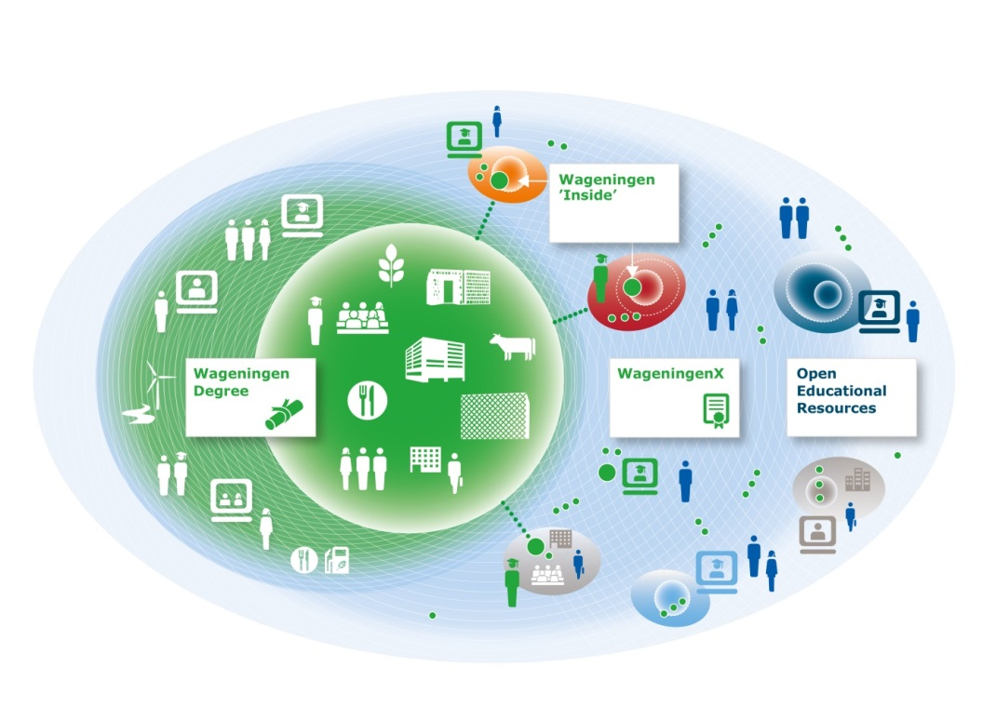

Figure 1: Visualisation of “Wageningen 2020: A learning ecosystem” (Wild *et al*., 2014)

But what does this imply for our study programme and our students? Which online activities are already used and what could be other interesting opportunities? And what will the consequences be of all these possibilities on our study programme? And with all these new opportunities it is challenging for students to design their own learning path and take responsibility for their choices. Content of study programmes might not be so fixed anymore, and perhaps this will change even more as the European labour market needs highly educated people, with jobs and professions that change and evolve continuously (Wild *et al*., 2014). Students have to adapt to these changes and have an abundance of choices. It is not easy for students to operate in this fast changing environment and therefor guidance in their study choices and learning process is desirable.

In the present paper, two examples of teaching methods will be elaborated: thesis rings and a BSc skills assessment. Thesis rings show how new online techniques are incorporated into teaching activities. The BSc skills assessment prepares students for a fast changing teaching environment and job market.

Thesis rings are an example of a teaching method that uses both online and face-to-face interaction and tries to enhance self-activation of the student. The BSc assessment shows an example how to make students more aware of their own responsibility for their study programme and future career. The thesis rings support students on their scientific learning path, whereas the BSc assessment guides students on their personal career path. In conclusion, the implications of new study methods will be discussed for the future of our educational system.

**Thesis rings**

BSc theses at the Wageningen University are rewarded with 12 to 24 ECTS credits (equivalent to 8 to 16 weeks), depending on the study programme. In case of the BSc Forest and Nature Conservation, a thesis is rewarded with 12 ECTS credits. The BSc thesis offers the student the opportunity to carry out an individual scientific research in the field of Forest and Nature Conservation, thereby using the knowledge and skills acquired during the BSc programme. Under supervision of a lecturer, students will write a research proposal, carry out the research, write the thesis and present and discuss the results at a plenary presentation session. The nature of the BSc thesis research varies widely from an experimental project, a data analysis project to a literature review project. Results will be compiled in a scientific report or article, and have to be presented orally (Heijmans, 2016).

A MSc thesis at Wageningen University is rewarded with 36 ECTS credits. Key to a MSc thesis is to execute all steps of a scientific research, under supervision. As for the BSc thesis, results are reported in a scientific report or in the format of an article. Two presentations are given here, both on the proposal and the final results.

Usually, a thesis proposal, chapters and draft report are reviewed a few times by an academic thesis supervisor, with main focus on scientific content. But both the student and thesis supervisor can encounter problems and challenges during this process. Some of most often encountered complications are the following ones:

From the viewpoint of the students:

* A student has problems with the writing process;
* Students with (writing) problems hesitate to contact a supervisor;
* Students do not want to bother supervisors too much;
* Feedback from supervisor might take time (availability).

From the viewpoint of the supervisors:

* A supervisor does not always have time for feedback or meetings due to other obligations (teaching, research, staying abroad);
* A supervisor wants to focus on scientific progress but to improve quality of the report, part of the time is also spent on feedback on writing skills, formulating proper questions and structure of the thesis;
* With increasing numbers of students supervising all students can be challenging.

Thesis rings can help to address some of these issues. Romme and Nijhuis (2002) described thesis rings in 2002. Their guidelines were adapted by Wageningen University. At Wageningen University there are different thesis rings, some are either for BSc or MSc students, but in some domains BSc and MSc students are mixed. For students of the BSc Forest and Nature Conservation a separate BSc ring started in November 2016. The rings are organised as peer review systems by students, where students have to review each other’s thesis proposals and chapters. Within a thesis ring, seven to ten students have a weekly, face-to-face meeting with an academic staff member, chairing the thesis ring. Each week one or two students upload a part of their thesis work, for example a research proposal or thesis chapter, on an online reviewing platform (e.g. Blackboard site). The other group members are obliged to review these documents online.

During the meeting the documents are discussed. One student will present his or her feedback and the other students add comments. The ring chairman controls safety, solves disagreements, is timekeeper and can give some general advice on scientific writing or structure. The rings are ongoing during the academic year. If a student starts with a thesis he/she will participate (obligatory) in an existing ring. If his or her thesis is finished, the student will leave the ring. Members of a ring can be in different phases of their thesis.

Based on experience from thesis rings at other study programmes we find that the rings are a good learning experience for the student. They learn the role of peer reviewers, identify common issues, become more reflective to their own report, they are able to give and receive feedback. Thesis supervisors notice that the quality level of research proposals and draft reports is increasing and therefor they can pay more attention to the scientific process.

The rings can be very useful for additional feedback and students get acquainted with other subjects. Usually there is a good atmosphere within a thesis ring. It is safe, fun, relaxed although the students have to work hard. The chairing staff member has to invest time in the meetings, but NOT in reading the documents. The rings are not the solution to handle larger number of students, but can be part of a solution. The role of the student, thesis supervisor and ring chairman should be clear and well defined. The rings require good organization and coordination with a proper supporting website (Gresnigt, 2015). If these conditions are met, thesis rings can definitely contribute to activation of students and enhance quality of theses as well.

**Self-assessment BSc students**

During the BSc Forest and Nature Conservation, and several other BSc programmes at the Wageningen University, students can participate in a professional assessment (1 ECTS credit) of their skills and their career motives. Students complete two online professional tests from an external assessment agency (Eelloo, 2017). One test distinguishes twelve career motives (see Table 1). These motives show which aspects are important for someone in a (future) job. What do you desire in a job? What is your driving force? Do you aspire a fancy career or is appreciation more important?

The other test shows the qualities of a student on eighteen different skills, e.g. planning, cooperating, flexibility, leadership.

Each student receives an extensive report with his or her test results. The results are elaborated with additional assignments, partly online and partly in small groups supervised by a study adviser. The assignments help students to discover the link between their career motives, skills, the choices they make in their study programme and their future career. What does it imply if you like working with other people, but you are not keen on competition? Which career fits best? Which skills are still weak and should be improved if you desire a career in science?

Students become more aware of their capacities. The tests, assignments and discussions are usually confirming what they already know but they become more confident.

Table 1. Career motives as described by an assessment agency (Eelloo, 2017).

|  |  |  |
| --- | --- | --- |
| **Motives** | **Motives** | **Motives** |
| Countenance (respect) | Security | Cooperation |
| Career | Learning | Autonomy |
| Competition | Perfection | Innovation |
| Influence | Appreciation | Meaningfulness |

At the end of the assessment students have to give two elevator pitches of only one minute during a meeting with a small group of fellow students and a study adviser; one pitch to present their ideas for courses they want to do during their BSc studies and one to apply for their (imaginary) dream job.

Sometimes students still expect that the job will come automatically and that they can just apply, but networking, showing that your input can make a difference, a bit competition, desiring a career and showing your skills become increasingly important.

Table 2 shows the results of the two strongest and two weakest motives of 46 students of the BSc Forest and Nature Conservation. Other students at Wageningen University are also assessed, but a comparison has not been made. As it can be seen from the table, the previously mentioned motives get low scores in the test results of our Bachelor students Forest and Nature Conservation.

The results of assessment and assignments can be confronting and challenging. The students are used to discuss and present scientific results, but hesitate to show their strongest motives and qualities. This becomes clear from the results as mentioned in Table 2, as the students are not that much interested in ‘being important’ (earning respect), ‘competitive’ or ‘influential’. In their final pitch about their imaginary dream job, they still downplay their own qualities, but at the end of the assessment they really value the experience and are more confident in choosing their study path and showing their skills. Within a fast changing job market this could be an import asset.

Table 2: Two strongest and two weakest career motives from 46 2nd year students of the BSc Forest and Nature Conservation (data from 2nd year students in 2014, 2015, 2016 and 2017).

|  |  |  |  |
| --- | --- | --- | --- |
| **Strong motive** | **# of students** | **Weak motive** | **# of students** |
| Perfection | 21 | Countenance (respect) | 31 |
| Appreciation | 18 | Competition | 26 |
| Meaningfulness | 17 | Influential | 12 |
| Learning | 10 | Career | 6 |
| Cooperation | 10 | Cooperation | 5 |
| Security | 6 | Autonomy | 4 |
| Autonomy | 5 | Learning | 3 |
| Influence | 3 | Appreciation | 2 |
| Career | 2 | Perfection | 1 |
|  |  | Innovation | 1 |
|  |  | Security | 1 |

**Development of study programmes and the educational ecosystem**

Both examples, the thesis rings and the BSc assessment, are still campus activities which use online tools and social media. But how will all the online tools influence our study programmes?

Online feedback is already common practice, but the feedback face to face, used with the thesis rings and BSc assessment, is valued by students. Both methods of feedback, online and face-to-face, from students and teachers, can be used in a blended learning system and adjusted to a student’s own needs and study tempo.

As part of their study programme, students can attend MOOCs from Wageningen University to obtain ECTS credits. In future it would be interesting for students to attend MOOCs from other universities as part of their studies. Especially in the broad domain of forest and nature conservation it is interesting to share knowledge and courses. Not all topics can be covered at all universities and students from Wageningen University are interested in more in-depth knowledge of e.g. forestry, dendrology, wildlife management and tropical forests. If they could attend MOOCs from other universities this would be a great opportunity. On the other hand, students are now keen to participate in exchange programmes such as Erasmus in order to get this knowledge. And going on exchange, experiencing another country, different education and culture, definitely has added value too, both for scientific and personal career opportunities.

As mentioned in the introduction, students need guidance and feedback in their scientific and learning path to make choices with all these different on campus and online opportunities.

But universities also have to decide what the boundaries of their study programmes are. What is offered on campus, online from home or external universities or institutes, or on exchange and when is it a certified, accredited study programme? With the BSc assessment, Wageningen University tries to enhance BSc students to become aware of their own motives and skills and take responsibility for their own learning path. The thesis rings help to acquire scientific skills in the BSc as well as in the MSc phase.

In a blended learning ecosystem, MSc students can look for cooperation with partner institutes, in situ or online, to enhance their skills and network. At the end of their MSc programme they are open minded and independent scientists-to-be, ready for a first assignment, but not necessarily a fixed job description.

And finally, as an alumnus, it is easier to stay in touch with your former university, for co-operations and lifelong learning to keep up with the changes at job market.

Wageningen University expects that on campus activities will still be important: BSc and MSc programmes are core businesses and centre points of the educational ecosystem. But the traditional campus setting will get more and more blended with online facilities from Wageningen University as well as from partner institutes and other universities. The campus will add value through enabling personal contact.

**Final remarks**

How will this international educational ecosystem function and how will it evolve? Ecosystems change, education too. Do we get more flexibility in curricula? Or will it be more building blocks instead of a prescribed degree? How will employers react? Do we change from teaching to providing diplomas or certificates? All these questions were also raised by Wild *et al*. (2014) in their report on this new learning ecosystem.

Should we share all our courses and curricula so students can build their own programme with courses, MOOCs, at campus, at other universities or online Erasmus exchange?

All these questions are raised during the permanent process of improving, adapting and organizing the educational system of Wageningen University. At the end of 2017, Wageningen University is working on a final paper on its vision on education.

But as mentioned before, experience or guidance online is not the same as face-to-face interactions. First of all, an exchange programme offers the opportunity to meet other people in your field of interest which is relevant in such an international field as Forest and Nature Conservation.

Secondly, field work and excursions are still an important aspect of our study programme to link science to real life.

And third and last remark, that regular contact between study adviser, teachers and fellow students will always be important, online or on campus, for guidance in study choices and learning process

But definitely there will be a change on campus life and education, but it will be an interesting educational ecosystem.

**References**

Eelloo, 2017: [www.eelloo.nl](http://www.eelloo.nl)

Gresnigt, M.C., 2015: Thesis ring network lunch, power point presentation, venue: Teachers Day Wageningen University, December 8, 2015

Heijmans, M., 2016: PEN-80812 BSc thesis Forest and Nature Conservation, Academic Year 2016-2017, internal document, September 2016.   
 <http://www.wur.nl/en/Expertise-Services/Chair-groups/Environmental-Sciences/Plant-Ecology-and-Nature-Conservation-Group/Education.htm>

Romme, A.G.L. and Nijhuis, J.F.H., 2002: Collaborative Learning in Thesis Rings. Internal document Tilburg University and Maastricht University

Wild, U., Gimbrere, M., Kuipers, A., Bakema, F., van der Pas, J. and Kelhout, E., 2014: Towards 2020: building an innovative learning eco-system. Internal document Wageningen University.

**EDUCATION AT THE FACULTY OF FORESTRY AND WOOD SCIENCES, CZECH UNIVERSITY OF LIFE SCIENCES PRAGUE – CURRENT SITUATION AND INNOVATIVE STRATEGY**

**JIŘÍ REMEŠ**

**Abstract**

This contribution aims to inform on the current situation and the new innovative educational strategy at the Faculty of Forestry and Wood Sciences (FFWS) Czech University of Life Sciences Prague (CULS). The FFWS is presented as modern, dynamically developing educational institution with a long tradition and a vision for the future. The number of students in Bachelor's and Master's programmes has stabilized at about 1,750 students. The new educational strategy comprises the development of teaching facilities together with new educational methods and study programme innovation. The former includes new modern classrooms as well as teaching laboratories. The latter is based on the innovation of study programmes in line with the needs and requirements both of forestry and wood industry and on implementation of the modern teaching methods (including e-learning).

Key words: Education in forestry and wood sciences, Faculty of Forestry and Wood Sciences Prague, structuring of the study, new teaching methods, increasing of the student motivation

**Introduction**

The Faculty of Forestry and Wood Sciences (FFWS) is one of the six faculties of the Czech University of Life Sciences Prague. It represents a modern, dynamically developing educational institution with a long tradition and a vision for the future. Forestry education has a long tradition in Prague, regular forestry lectures were started at the Polytechnic University already in 1848. The independent branch of Master’s studies in forestry was established in 1919.

Nowadays this faculty provides a comprehensive forestry education system to encourage and support rational forest management and sustainable utilization of its huge natural resources. FFWS has become a respected international research centre. Students learn both in-depth theory and practice to be well-prepared for future challenges in forestry, wood processing industry and research. The year 2015 was very important for the FFWS with regard to the acquisition of the RDI project as the granted CZK 280 million (= 10.5 million €) was used to build a new FFWS Pavilion of Wood Sciences and Technologies and equip it with state-of-the-art technology for teaching as well as scientific and research purposes.

At present, the FFWS has six accredited Bachelor programmes and two follow-up Master programmes, taught in Czech, and three accredited Bachelor programmes and four follow-up Master programmes, taught in English.

FFWS offers for all subjects accredited postgraduate (PhD) studies in Czech and two in foreign languages. The former is the Forestry Engineering PhD programme, including Silviculture, Forest Biology, Forest Protection and Game Management, Forest Management, Wood Processing and Machinery in Forest Management. The latter is the Economics and Management PhD programme including Economics and Management of an Enterprise.

For a long time, the double degree programmes (DD programmes) have been a stable part of studies offered at the FFWS. Currently, three contracts for the implementation of DD programmes have been signed. Two of them are with the Faculty of Forestry (Escuela Técnica Superior de Ingenieros de Montes) of the Technical University of Madrid with two subjects: Forestry, Water and Landscape Management, and Forest Engineering.

**Interest in studies at the FFWS**

The admission rate of students is markedly influenced by the downward demographic curve in the Czech Republic (Figure 1). It is obvious that freshman years at universities touched the bottom of the demographic decline and now the students born in years with a historically lowest fertility rate in the Czech Republic commence their university studies (Figure 1). This adverse situation will last for about another six years. Only then we can expect a gradual increase in the number of applicants for university studies.

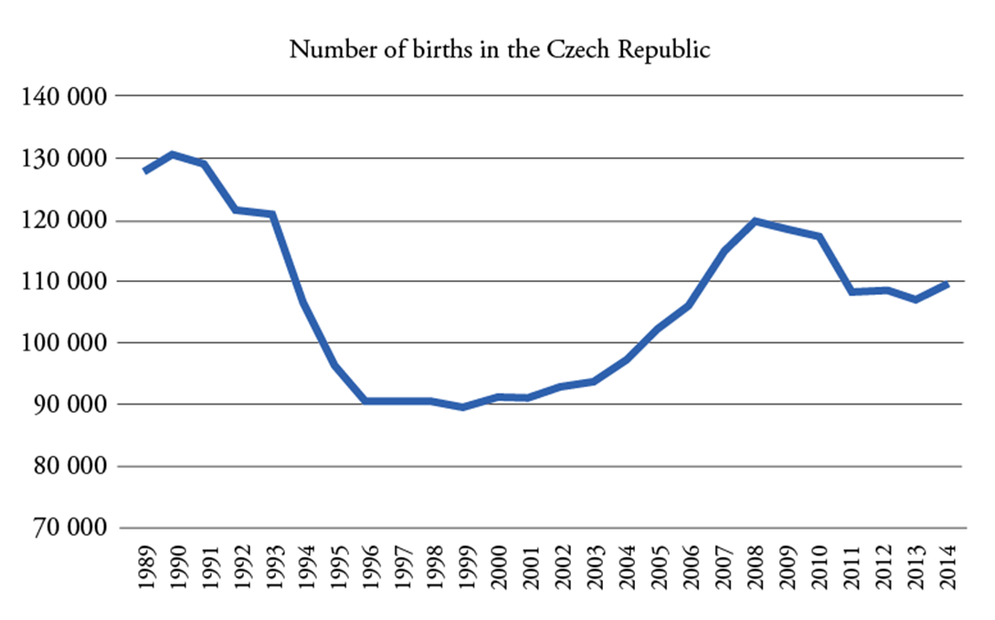

Figure 1: Number of births in the Czech Republic after 1989 (data of the Czech Statistical Office, 2015).

One of the major strategic objectives of the faculty is to maintain the current number of students despite the decreasing number of potential applicants. The total number of newly admitted students increased slightly in 2015 as compared to 2014 (Figure 2). It is the result of intensive work on the promotion of studies at the FFWS. Because of the economic boom the number of unemployed graduates of the FFWS remained very low in 2015.

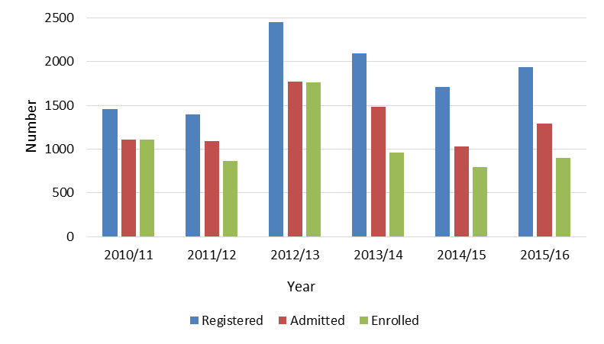

Figure 2: Development of the number of registered, admitted and enrolled students between 2010 and 2015 (Anonymous, 2015).

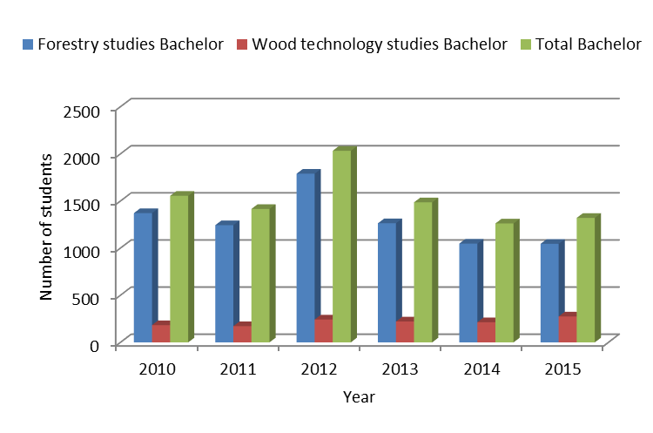

Figure 3: Total number of students enrolled in Forestry and Wood Sciences programmes at Bachelor level between 2010 and 2015 (Anonymous, 2015).

An overview of trends in the number of students in the forestry and wood sciences programmes is shown in Figures 3 and 4. It is obvious that the number of students studying wood sciences at Bachelor level is gradually increasing slightly and is not subjected to such variations as the number of students studying forestry. This increase is also related to the gradual launch of a study programme Business in the Wood Processing and Furniture Industry. However, the number of students enrolled in forestry Bachelor programmes was successfully stabilised over the past two years.

In the follow-up Master’s degree studies, there has been a greater volatility in the number of students over the past six years. The highest numbers were achieved in 2012 and 2013, whereas in 2014, a fairly significant decline was recorded. In 2015, the decline was compensated, in particular, by an increase in the number of students in the forestry study programmes. In the Wood Engineering, however, the decline in the number of students continued even in 2015.

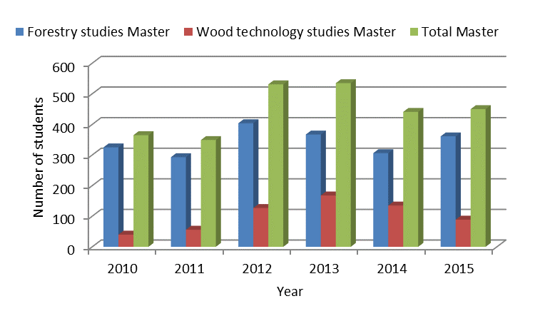

Figure 4: Total number of students enrolled in Master’s programmes Forestry and Wood Sciences between 2010 and 2015 (Anonymous, 2015a).

**Innovation in the education strategy at the FFWS**

Priorities in the education strategy are defined in the update of the Long-term Plan of the Faculty for 2015 (Anonymous, 2015b) and focused mainly on the following items:

* *Stabilising the number of students* of Bachelor’s and Master’s degree programmes, increasing the attractiveness of studies at the FFWS;
* *Improving the educational process* with the aim to increase the success rate of students in their studies;
* *Intensifying cooperation* with other universities in the area of educational activities;
* *Developing lifelong training programmes and courses* for the staff of public and private companies in the fields of forestry and wood sciences;
* *Assessing the employment and employability of FFWS graduates*.

The above mentioned priorities are driven by the effort to transform the FFWS into a modern educational institution standing on three pillars: gifted students, high-quality teachers and well employable graduates.

A high failure rate has been a major problem of the FFWS over a long period of time. Highly demanding studies, insufficient motivation and often even a small learning potential of the FFWS students played their part. Close attention has been thus paid to the issue of reducing the study failure rate at the FFWS over recent years. After analysing the causes of this failure rate, mainly the following causes were identified: insufficient competence of newly admitted students for studies at the FFWS, the complexity of some subjects, study structure (curricula), poor motivation of students to study and poor availability of both technical equipment and teaching materials) conditions under which learning takes place. The remedies to this adverse situation has been aimed at all selected areas:

* *Recruit for studies* at the FFWS talented students who have the learning potential for university studies. It includes the promotion by FFWS and its study programmes together with enhancing graduates’ employability, and the gradually increasing demands in the admission procedure. This will concentrate the number of students admitted to the study to those students, who have the best competences. Moreover, the educational counseling for students together with more intensive communication with students can reduce the study failure rate.
* *Structuring of the study* so that the composition of the study subjects would correspond with the graduates’ profile and the specificity of individual curricula (diversification of studies) while the study load would be evenly and in a balanced manner distributed over all years of the curricula. In order to achieve this goal, the following measures have been taken: optimising of the study programmes at FFWS, partial modifications (reshuffling of courses) in curricula, preparation and implementation of additional seminars and courses for more difficult subjects, spreading the study over a longer period of time.
* *Increasing of the motivation* and interest of students. This is considered to be the main means in achieving better learning outcomes. The chief tools used to enhance the study motivation at the FFWS include: scholarship programmes, the development of active and talented students, supported also through extracurricular activities, the promotion of cooperation with the forestry practice and wood industry to stimulate internships to increase the employability. All these activities can be summarized as making learning more attractive.
* *Gradually improving study conditions* and *optimising the process of teaching* as such. It is the key for all the necessary specialisations to be taught by the best professionals with high-quality teaching capabilities. With the use of all available resources this includes: active support of updating and preparation of study materials, more active evaluation of the quality of teaching, the gradual enhancement of the pedagogical "expertise" of FFWS academics, gradual improving of the technical and material background of the educational process.

For the solution of these problems the new innovation project for the next six year (2017-2022) was developed in 2016. It includes:

* Building fifteen new laboratories for teaching;
* Innovate three current study programmes;
* Preparing two new study programmes (Arboristics, Wooden structures and buildings based on wood);
* Implementing modern teaching methods:
  + increase number of study subjects taught in English,
  + support new teaching methods,
  + increasing the skills and competencies of academic staff,
  + prepare new study materials,
  + develop and apply e-learning including uploading of e-learning courses on Moodle (<http://moodle.czu.cz>), and using the database ebrary (www.proquest.com) – electronical books from two collections: Science & Technology (more than 20 000 titles from Biological Sciences, Agriculture, Forestry, Zoology and others), and Business & Economics (more than 19 000 titles from Economy, Management, and others).

**Conclusion**

The Faculty of Forestry and Wood Sciences of the University of Life Sciences (Prague) offers study programmes in forestry and wood sciences, including issues relevant to public administration and enterprises, or associated with game management and other forest and landscape components, including management of forests in protected landscape areas. The essence of all study programmes is the implementation in the students’ minds of the principles of sustainable management of natural (renewable) resources aimed to harmonise the ecological principles of landscape management with the requirements of the society for all forest products and services. The in 2016 updated innovative strategy in education comprises new structuring of the study programmes and courses, increasing of the motivation and interest of students, improving study conditions and optimising of the teaching process. A six-years programme was developed to fulfil this strategy for the period (2017-2022). The measures included in this programme will allow adaptation of the study to the new legislative conditions in the Czech Republic (amendment to the Higher Education Act was adopted in 2016). Moreover, we expect that this programme can sufficiently increase the attractiveness and effectiveness of the FFWS to become one of the top educational institutions in the field of forestry and wood industry in Central Europe.

**References**

Anonymous, 2015a: The Annual Report 2015 the Faculty of Forestry and Wood Sciences CULS Prague. Prague 2016, 118 p.

Anonymous, 2015b: <https://www.fld.czu.cz/cs/r-6823-o-fakulte/r-6821-oficialni-dokumenty/r-8690-dlouhodobe-zamery>). Addressed April, 2017.

Czech Statistical Office 2015: Population – annual time series. Available on: <https://www.czso.cz/csu/czso/population_hd>. Addressed April 2017.

**UNDERSTANDING FORESTRY STAKEHOLDERS’ AND PRACTITIONERS’ EXPERIENCES AND PERSPECTIVES ON LEARNING AND EDUCATION FOR FUTURE FORESTRY**

**SARAH POHLSCHNEIDER AND PHILOMENA DE LIMA**

**Abstract**

Forestry world-wide makes a fundamental contribution to environmental, social, wellbeing and economic objectives but will be subject to uncertainty and complex challenges. More than ever educational institutions offering forestry courses are urged to educate future forestry professionals who have the capacity to address the complex roles that forestry is increasingly required to perform. The forestry sector in Britain appears to be experiencing a rising demand for a skilled workforce while students’ interest in pursuing forestry careers declines. Thus, improving recruitment and providing future practitioners with relevant education and skills are a major concern. Much of the research on the labour requirements of forestry has tended to focus on the supply side (e.g. forest industry and universities) encompassing competing views on how forestry is conceptualised and understood. Providing an alternative approach, this on-going qualitative study elucidates forestry professionals’ experiences and perspectives regarding their conceptualisation of forestry, career and skills required for the future of forestry in Britain. Drawing on in-depth interviews and a very preliminary analysis of the data emergent findings are identified to provide the basis to conceptualise and contextualise interviewees’ experiences in a broader education discourse. Understanding practitioners’ views is a step towards a more holistic concept of forestry fit for the 21st century.

Key words: Forestry education, skills, multifunctional forestry recruitment, careers, reflective practitioner

**Introduction**

A globalised world, climate change, increasing industrialisation and consequent specialisation in forestry roles and labour requirements have been important in transforming various stakeholders’ perceptions of forestry and what it means to be a forestry professional. The profession is at the interface of ecological, social and wellbeing and economic interests. Therefore, the need to educate future foresters in the context of increasing complexity and uncertainty is urgent. Encouraging different pedagogical approaches to education, including encouraging individuals to be active learners and promoting lifelong learning are identified as essential in addressing the upcoming challenges. However, enabling individuals to become self-active learners is a complex and cross-disciplinary topic. One aspect of learner self-activation could encompass a critical reflection of learners’ perceptions in relation to their profession and the role forests and forestry play within society. Building reflective capacity of students in their early years of study could contribute to developing a much needed integrated view of natural resource management and overcoming disciplinary boundaries. However, most studies pertaining to forestry skills, education and recruitment focus on the views of productive forest industry and education providers. Declining student enrolment and the perceived skills mismatch between drivers of change, education provision and industry demands are complex phenomena that need to be considered in wider social and ecological contexts.

Taking an alternative approach, the overall aim of the ongoing PhD study is to understand the implications of multifunctional forestry on future recruitment and skills requirements from forestry professionals’ point of view. This paper presents some very preliminary findings drawn from in-depth interviews with forestry professionals reflecting diverse forestry interests and sectors. The aims of the interviews are to elucidate their past careers and provide their perspectives on issues related to skills as well as their visions of future forestry. In the light of the 2016 conference topic ‘the activation of the learner’, observations pertaining to the core focus of the conference shall be highlighted in this paper. The paper starts off by introducing the forestry sector in Great Britain, followed by a brief outline of the adopted methods and the findings, ending with a conclusion suggesting alternative approaches to professional education in relation to learner activation and the building of reflective capacity among learners.

**The British forestry sector**

British forestry compared to other European countries is a rather recent phenomenon. After severe timber shortages during the First World War and a forest cover of as low as five percent, the UK government created the Forestry Commission in 1919 to provide a strategic timber reserve. At present the UK’s woodland cover has been expanded to 13 percent and forestry is regarded as a vital contributor to the land-based economy. For example, the Scottish Government declared ambitions to decreasing timber imports whilst increasing total woodland coverage by 10,000 hectares per year (Forestry Commission, 2011; Scottish Executive, 2006).

Despite its established role in the economy, society and environment, the British forestry sector faces fundamental workforce issues. One concern is the above average workforce age giving rise to an increasing number of forestry staff retiring over the next decade. This, it is argued, is likely to create an acute need for well-trained forestry graduates to replace retiring workforce (Breuer, 2012). Another issue that is highlighted is the higher than average number of vacancies within the sector attributed to unattractive working conditions or applicants lacking necessary skills. Overall, surveys suggest that employers perceive graduates as lacking, amongst other factors , general management, business, organisational and interpersonal skills as well as practical experience and silvicultural knowledge (e.g. Forestry Commission England, 2011; Breuer, 2012). Despite the need for graduates as articulated by some productive forest industry, educational providers are finding themselves in a precarious situation as student enrolment into forestry or related programmes at further and higher education institutions have declined over the past decades (Innes and Ward, 2010). Public perceptions of forestry as a conservative, old fashioned profession with little career opportunities and as a low paying ‘3D profession’ (dangerous, dirty and demanding) are deemed to negatively influence student recruitment (Breuer, 2012).

Declining student numbers has had severe consequences for course funding at universities, resulting in a constant reduction and amalgamation of existing forestry courses with related environmental or natural resource science study programmes. Thus, the overall integrity of forestry as a concept is shaped by the co-existence of different conceptualisations: as a vocational profession, an academic discipline or as an integral part of broader natural resource management (Leslie *et al*., 2006). Walmsley *et al*. (2015) also warn that numbers of forestry specific staff at higher education institutions are reduced with severe consequences for research activities in the forest sciences, further lowering the profile of forestry as an academic discipline.

However, the development of forestry from a product-centred industry to a multifunctional discipline (i.e. incorporating social, economic, environmental /ecological, etc. aspects) has fuelled academic discourses, revealing a mismatch between forestry curricula and current and future demands of society and environment (e.g. Arevalo *et al*., 2014; Bullard *et al*., 2014; Innes and Ward, 2010; Leslie *et al*., 2006; Miller, 2004; Nair, 2004; Ratnasingam *et al*., 2013). Linear, steady state assumptions of ecosystem interactions have been replaced with an integrated view of diverse and complex socio-ecological systems that will be confronted with uncertainty and unpredictable challenges (e.g. Lawrence, 2016; Puettmann *et al*., 2016). Furthermore, the short and dynamic policy cycles shaped by specific political interests are seen to conflict with the long term planning required if forestry is to be successful in meeting its multifunctional role. In this context securing appropriate recruitment into the forestry professions and transforming education and skills training to ensure that forestry professionals are adaptable and capable of functioning in complex and dynamic contexts is essential.

**Methods**

Drawing on a phenomenological approach, the study adopted a qualitative research design to understand the factors shaping forestry practitioners’ and professionals’ career choice making, including their views on professional development in the context of their careers as well as their views on skills needed with respect to forestry and their vision of the future of forestry. In-depth, semi structured interviews were conducted with 21 interviewees which were audio recorded based on interviewee consent. The sampling of interviewees was informed by an extensive literature review, a segmentation study of the British forestry sector (Eves *et al*., 2013) and snowball sampling (e.g. Bryman, 2012; Ritchie *et al*., 2013) to capture the diversity within the sector. The audio recordings were subsequently transcribed and preliminarily coded as broad themes (current stage). The latter will be further refined and subject to detailed analysis using an adaptive approach to thematic analysis (e.g. Bryman, 2012; Layder, 2005; Ritchie *et al*., 2013).

**Initial findings**

As this study is ongoing[5], it is important to emphasise the very preliminary nature of the findings which must be treated with caution and should not be considered as a comprehensive analysis. However, some reoccurring views on learning and the future of the forestry sector shall be discussed in the light of the theme of the 2016 SILVA Network conference, activation of the learner.

In general, interviewees felt that forestry’s contribution to economy, society and ecology will continue to grow as demand for, for example, wood fuel and recreational opportunities, expand. However, unresolved and interconnected issues around climate change, forestry related policy development and invasive pests and diseases are perceived as creating uncertainty in the future. Interviewees noted that coping with future challenges may require, amongst other issues, diversification and adaptation of management scale and practices, decisions on appropriate tree species choices, addressing landownership patterns, and establishing integrated objectives across the land based sectors. However, communication and collaboration across the land based sector is reported as being affected by the tendency to think within disciplinary or sectoral boundaries (‘silo thinking’) resulting from conflicting interests (optimal deer population density and competition for land). One of the interviewees, despite being raised on a farm, referred to the divide:

“*I think that there's a—, a problem with seeing things through somebody else’s eyes perhaps, so we're wearing blinkers. So as a forester you tend to only see problems from a forestry point of view and maybe from agriculture, you only see it from an agricultural point of view.” (Brandon[6], college lecturer and machine operator)*

Interviewees were encouraged to describe the identification of skills gaps along their careers. Some interviewees used formalised Continuous Professional Development (CPD) offered by employers or professional bodies, while others stressed ongoing on the job skills gap identification. In addition, interviewees’ activity levels in identification processes varied greatly from actively reflecting on skills and knowledge gaps beyond immediate job requirements to passively following employer demands. Egon took a critical stance on the matter, calling for more proactive, reflective approaches:

*“What do we know? What don't we know? What are the gaps? Where can we find that information? […] Well, [exhales] I don't get the sense that forestry professionals particularly are doing that, assessing gaps in their knowledge. […] You try to pick up interesting things, you try and make sense of them in the context that you've already developed and built up.” (Egon, Policy Advisor-public conservation agency)*

Egon along with other interviewees emphasised that careers in forestry imply an obligation to and an embracing of lifelong learning. However, some interviewees expressed concern over a perceived disconnect between their professional education and job reality, resulting in a steep learning curve in their first professional position. These interviewees also reported that developing necessary competencies and contextualising knowledge within work settings relied on various processes and media, ranging from institutionally based options (such as CPD, conferences and memberships of professional bodies) to unstructured and informal learning experiences. Among the latter especially the opportunity to make and learn from mistakes was mentioned. Douglas highlighted the positive effects of learning from mistakes in work settings and stressed its necessity, especially for the future:

*“[T]here's a danger that we're gonna [sic] have forests developing diverse-, resilient woodlands developing and I think there is a danger that management skills are going to be lacking for that. […] The people do need to get an opportunity to get their hands dirty and, and do things in the woodland and learn from their mistakes.” (Douglas, self-employed consultant)*

While interviewees recognised making mistakes as a valued learning experience, they also warned that current students are perceived to lack opportunities to gain practical experience. Creating these opportunities was regarded as a vital task for education providers and future employers.

**Discussion**

As described above, interviewees felt that responding to future pressures required adapting current forestry practices and considering options beyond professional boundaries. Further, interviewees expressed that making mistakes was a valuable source of on the job learning. Identifying skills gaps varied extensively in relation to workplace circumstances and personal preferences and abilities. Initial analysis of the interviews suggest that facilitating individuals to establish reflective capacity and critical thinking may facilitate having to cope with future developments and complexity in the context of a dynamic and uncertain context . However, forestry is not the only sector that is experiencing discrepancies between education and job realities magnified by future uncertainty and increasingly complex circumstances and so there may be opportunities to learn from other sectors and disciplines.

Approaches suggested in other sectors within the academic community such as engineering, medicine and accountancy could help to enrich the forestry education and training situation. Advocating learner centred teaching methods to enhance motivation in engineering students, Felder *et al*. (2011) argue that effective active learning involves action and reflection. While forestry practitioners and professionals in this study called for more practical opportunities for forestry students, there should also be efforts made to include reflective elements to ensure effective and contextual learning that can be continually adapted to changing contexts. A study in accountancy and business studies suggests that a change in inter- and intra-personal belief systems within work-based settings could foster reflective capacity (Lucas and Leng Tan, 2009). Furthermore, given the views on silo thinking that were highlighted by forestry professionals interviewed for this study, building reflective capacity might be more appropriate given the interdisciplinary nature of issues that the sector has to address as well as in the light of calls for a more integrated approach to the land based sectors. Another study developed a reflective thinking assessment tool kit based on students’ reflective writing skills to ensure professionalism and critical thinking skills among medical students (Wald *et al*., 2012). Wald *et al*. (2012, p. 6) broaden the question of “How do doctors think” to “How can we make doctors think” to facilitate a wider view of metacognitive skills and professionalism. In the context of uncertainty and challenges of the future, problem solving abilities in relation to forestry professionals might be enhanced using reflective approaches.

These examples highlight that the need for integrating reflective capacity is felt across a variety of academic disciplines. Encouraging students to actively become reflective practitioners could be a step towards dealing with the uncertainties and challenges of the 21st century.

**Acknowledgements**

This article is based on an ongoing PhD at the University of the Highlands and Islands-Inverness College, funded by the Forestry Commission, Forestry Commission Scotland and The Scottish Forestry Trust. The project is supervised by Dr Philomena de Lima, University of the Highlands and Islands, Inverness College; Dr Donald Gray, University of Aberdeen; Dr Bianca Ambrose-Oji, Forestry Commission, Forest Research. We would like to thank all the interviewees of the study for their time and cooperation.

**References**

Arevalo, J., Pitkänen, S. and Kirongo, B., 2014: Developing Forestry Curricula: Experiences from a Kenyan-Finnish Project. International Forestry Review 16:78–86.

Breuer, Z., 2012: Agriculture, Forestry & Fishing: Sector Skills Assessment 2012, UKCES/Lantra, Wath Upon Dearne.

Bryman, A., 2012: Social Research Methods, 4th Ed. Oxford University Press, New York.

Bullard, S.H., Stephens Williams, P., Coble, T., Coble, D.W., Darville, R. and Rogers, L., 2014: Producing ‘Society-Ready’ Foresters: A Research-Based Process to Revise the Bachelor of Science in Forestry Curriculum at Stephen F. Austin State University. Journal of Forestry 112:354–60.

Eves, C., Johnson, M., Smith, S., Quick, T., Langley, E., Jenner, M., Richardson, W., Glynn, M., Anable, J., Crabtree, B., White, C., Black, J., MacDonald, C. and Slee, B., 2013: Analysis of the potential effects of various influences and interventions on woodland management and creation decisions, using a segmentation model to categorise sub-groups. Volume 3: Woodland management segmentation and assessment of interventions. Defra, London.

Felder, R.M., Brent, R. and Prince, M.J., 2011: “Engineering Instructional Development: Programs, Best Practices, and Recommendations.” Journal of Engineering Education 100:89–122.

Forestry Commission, 2011: The UK Forestry Standard. Forestry Commission, Edinburgh.

Forestry Commission England, 2011: Forestry Skills Action Plan. Available at: [www.forestry.gov.uk/pdf/ForestryActionPlan_web.pdf/$FILE/ForestryActionPlan_web.pdf](http://www.forestry.gov.uk/pdf/ForestryActionPlan_web.pdf/$FILE/ForestryActionPlan_web.pdf) [Date last accessed 01/03/2017]

Innes J.L. and Ward, D., 2010:. Professional education in forestry. Pp. 76-93 in Commonwealth Forestry Association (Ed.) Commonwealth Forests. Commonwealth Forestry Association, Shropshire.

Lawrence, A., 2016: Adapting through Practice: Silviculture, Innovation and Forest Governance for the Age of Extreme Uncertainty. Special Issue on Forest ownership change: trends and issues. Forest Policy and Economics.

Layder, D., 2005: Sociological Practice - Linking Theory and Social Research. Sage, London.

Leslie, A.D., Wilson E.R. and Starr, C.B., 2006: The Current State of Professional Forestry Education in the United Kingdom. International Forestry Review 8:339–49.

Lucas, U. and Leng Tan, P., 2009: Developing a Reflective Capacity: Insights from Work-Based Learning. Centre for Business Performance, London.

Miller, H., 2004:Trends in Forestry Education in Great Britain and Germany, 1992 to 2001. Unasylva 55:29–32.

Nair, C.T.S., 2004: What Does the Future Hold for Forestry Education? Unasylva 55:3–9.

Puettmann, K.J., Parrott, L. and Messier, C., 2016: Teaching Complex Adaptive Systems Science in Natural Resource Management: Examples from Forestry. Natural Sciences Education 45:1–7.

Ratnasingam, J., Ioras, F., Vacalie, C.C. and Wenming, L., 2013: The Future of Professional Forestry Education: Trends and Challenges from the Malaysian Perspective. Notulae Botanicae Horti Agrobotanici Cluj-Napoca 41:12–20.

Ritchie, J., Lewis, J., McNaughton Nicholls, C. and Ormston, R., 2013: Qualitative Research Practice. Sage, London.

Scottish Executive, 2006: The Scottish Forestry Strategy. Forestry Commission Scotland, Edinburgh.

Wald, H.S., Borkan, J.M., Scott Taylor, J., Anthony, D. and Reis, S.P., 2012: Fostering and Evaluating Reflective Capacity in Medical Education: Developing the REFLECT Rubric for Assessing Reflective Writing. Academic Medicine 87:41–50.

Walmsley, J., Savill, P., Burley, J., Evans, J., Horsey, R., Leslie, A., Falck, J., Innes, J. and Waterson, J., 2015: Forestry in British Higher Education. Quarterly Journal of Forestry 109: 268 – 273.

**ESTONIAN FORESTRY STUDENTS’ PRE-STUDY BACKGROUND AND THEIR INTEREST IN EXCHANGE STUDIES ABROAD**

**MEELIS TEDER AND VAIKE REISNER**

**Abstract**

In higher education, internationalization is one of the hot topics. Universities are preparing full programmes or at least some special courses targeted to exchange students taught in English. The availability of courses in English is also an important assessment criterion for the higher education accreditation, at least in Estonia. Despite the efforts made by universities, the Estonian forestry students, at least at the beginning of their studies, are not interested in or motivated for attending exchange study programmes in foreign universities. The majority of forestry related students are from rural areas or they consider themselves as rural persons. In comparison, two forestry related student groups – forestry and natural resource management students – have differences in pre-study practical experience and application priorities.

Keywords: forestry education, practical experience, opinion survey, studies abroad, motivation and interests.

**Introduction**

In Estonia, forestry related higher education is provided by the Institute of Forestry and Rural Engineering of the Estonian University of Life Sciences in Tartu. There are two forestry related Bachelor level curricula – Forestry and Natural Resources Management (further NRM). Each has a duration of three years. At Master level, forestry is split into two different study programmes: Forest Management and Forest Industry; additionally there is a separate curriculum in NRM. All have a duration of two years. Since September 2015 there is also a new professional higher educational curriculum – Wood Processing Technology, which is a four-year programme at the Bachelor level. Additionally, a new MSc level curriculum, Forest and Nature Management, is being prepared, with English as the language of instruction.

Since 2007 there has been a continuous decrease of the number of schoolchildren graduating from upper secondary schools, which has resulted in diminishing numbers of students enrolled to the first level higher education (on national level 15,200 in 2007 versus 9,800 in 2015). The same tendency, the decreasing number of enrolments, can also be seen for forestry students (Figure 1). Additional influence to the number of students is related to the reform of higher education since enrolment in 2013, when the tuition fees were abolished and all the higher education is free of charge (Tullus and Reisner, 2015). Earlier, in the majority of specialities (including forestry related programmes) students with grades lower than the required minimum for free studies, could get a privately-financed study place.

Internationalization of forestry education has been widely discussed in different Silva Network meetings. Currently internationalization has several meanings:

preparing the entire curricula or some courses in English to attract foreign students;

within the period of studies in their home university the student is going abroad as an exchange student for a short period.

Internationalization is also one criterion of the accreditation of study programmes, at least in Estonia. As shown by Tullus and Reisner (2015), the Assessment Committee of Estonian forestry education suggested to improve marketing of the forestry education curricula and to use more English in study programmes. Thus a small number of universities are making some efforts in attracting foreign students. But are students interested in participation in exchange programmes? In the current paper we introduce some background and specialization selection criteria of the forestry related students in the Estonian University of Life Sciences and then we will focus on the students’ statements regarding attending foreign universities as an exchange student.

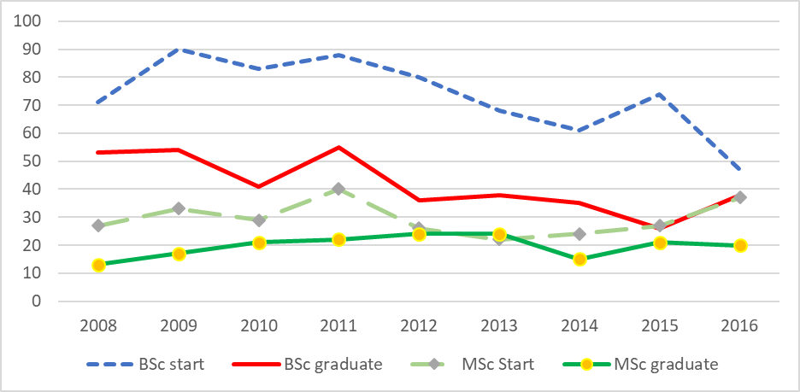

Figure 1. Enrolment and graduation numbers of forestry students in Estonian University of Life Sciences (Forestry BSc and summarised values for Forest Management and Forest Industry MSc students).

**Method**

Forestry students’ surveys in Estonia started in the autumn of 2009, after the massive layoffs in Estonian state forest management organization RMK (In Estonian – Riigimetsa Majandamise Keskus – State Forest Management Centre). The aim of the first survey was to find out the forestry students’ knowledge about the major reforms in the forestry related labour market and its influence to forestry students. An additional aim was to find out the students’ expectations entering the labour market and what the students think about their strengths and weaknesses compared to the other group of job seekers: unemployed forestry specialists, who have remarkable professional experience.

Later, the questionnaire has been developed further and it has turned into a longitudinal survey. The questionnaire is not anonymous, because one aim is to measure the changes in students’ personal opinions at the beginning and at the end of BSc studies. Respondents answered nearly the same questions during the first semester and during the sixth semester.

Below, we will observe the data of four groups of students: first year BSc students, who started their studies in 2013 (further referred to as 13) and 2015 (further 15). There are 164 respondents in total, in groups as follows:

* Forestry students: Forestry 13 – 61; Forestry 15 – 62;
* Natural Resource Management students: NRM 13 – 28 and NRM 15 – 13.

In some questionnaires the respondents only have the possibility of indicating their background as urban or rural. These possible answers might be evaluated differently, as the understanding of rural life might be different in a rather urbanised country (like for instance Belgium) compared to a country like Estonia. In Estonian rural areas, in bigger villages there are remnants from the former collective farms period, where some residents were living in multi-storey blocks of houses with district heating. A traditional Estonian rural dwelling has firewood heating, so people living there get used to deal at least with some wood assortments. Thus we developed a framework, where respondents can select four potential answers:

* I grew up in a town (urban area) and consider myself an urban person (Further on Figure 2 URB-Urb);
* I grew up in a town (urban area), but consider myself a rural person (URB-Rur). This might be the answer of students whose grandparents or other close relatives are living in rural areas and whom the students are visiting rather often (e.g. weekends or long summer vacations);
* I grew up in the countryside, but consider myself an urban person (RUR-Urb). This might be the answer of persons who are living in rural areas, e.g. in multi-storey houses with district heating, but whose parents are working in urban areas and since childhood the children have been commuting to urban kindergartens and schools;
* I grew up in the countryside and consider myself a rural person (RUR-Rur).

**Results**

*Origin and pre-study forestry experience of students*

From all the forestry related students the largest group is originating from rural areas and they consider themselves rural persons (Figure 2). While dividing respondents according to the prevailing mentality to rural (RUR-Rur and URB Rur) and urban (URB-Urb and RUR-Urb), the majority of forestry students in different years seem to be rather homogenous groups – 72% identify as rural persons (and 28% as urban persons) and the same proportion is found in both forestry student groups. The smaller group of NRM students is not so homogenous: 61% of all the NRM students declare to have rural mentality, but in 2013 the rural-urban mentality proportion was equal (both 50%), while two years later the group was nearly two times smaller and the proportion was 85% and 15%. The rural-urban mentality proportion of all the respondents is 69% to 31%.

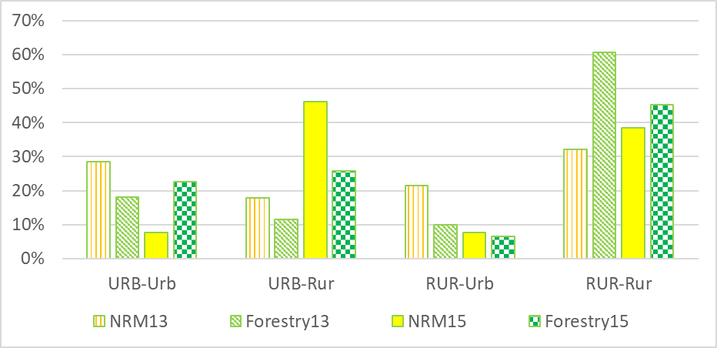

Figure 2. First year forestry related students’ background (for codes cf. Method).

Before the studies, an average of 72% of forestry students (Forestry 13 - 70%; Forestry 15 - 73 %) have had some experience of practical forestry activities, while for NRM students it was only 51% (57% and 38%). According to the specification of the survey question, the practical activities had to be long lasting or happened multiple times, single visits (e.g. an educational day in forest, which included some forest planting) had to be excluded. 62% (Forestry 13 - 61%; Forestry 15 - 63%) of forestry students have helped their parents or close relatives, who are private forest owners, with some practical forest management related activities; the respective figure for NRM students is 29% (46% and 23%). Additionally, 22% of forestry students and 9% of NRM students reported that their parents or close relatives are entrepreneurs, whose business offers different forestry related services and students have officially worked there or just helped them. Thus, by background and before-study practical experience Estonian Forestry students are more homogenous than NRM students.

*Study applications*

Nowadays students have the possibility to apply for admission for an almost unlimited number of study programmes in different Estonian universities. Applications are submitted by an internet based admission system, where the main universities and some vocational educational institutions are involved. Students fill in applications where they indicate the study programmes, which they would like to attend. Other required information, e.g. grades from previous level(s) of studies, are transferred from other national information systems. All universities have set up their own entry requirements for the different curricula. For example, for Forestry and NRM students there are three different criteria: results of national exams of Estonian language and generally mathematics and the average grade of the school-leaving certificate, while for the engineering students of the same institute, Institute of Forestry and Rural Engineering of the Estonian University of Life Sciences, the requirement is more specific mathematics (i.e. a more thorough, wider programme in the upper secondary school) with the minimum result of 20 points from 100. After the admission deadline the applicants’ ranking is done based on the afore named criteria. For admitted applicants of the first round there will be a deadline, when they have to confirm their willingness to study, e.g. if a student got accepted for four different curricula, they have to accept one of them and they will be excluded from the ranking of the three other curricula. Then there will be a second round of selection to the vacant places after the first round, where the next persons from the ranking list will have the possibility to confirm their choices.

In the Estonian admission system applicants are not making their list of priorities, but in our survey we were interested in their own ranking. We asked students about the number of study programmes they applied for in the survey year, and also in which place of their own ranking the current study programme was. Nearly a third of the respondents (37%) applied for two study programmes, followed by three (22%), one and four study programmes (both 14%). There were also a few students who applied even for seven or eight study programmes. Nearly two thirds (68%) of students are studying in the study programme that was their primary field of interest (Figure 3). There is an obvious difference between Forestry and NRM students, 77% of Forestry students ranked their current study programme as their primary field of interest and 22% of them applied only for this study programmes, while 41 % of NRM students are studying according to their primary field of interest and 2% (one NRM student) applied for this study programme only.

|  |  |
| --- | --- |
|  |  |

Figure 3. The total number of applied study programmes and the rank of the current study programme.

*Plans after BSc studies*

In Estonian higher education the 3+2 system (three years for BSc study programmes and two years for MSc study programmes) is mostly used. The first year BSc students were asked at enrolment, whether or not they have a plan to continue in a MSc programme or are planning to start working. 71% of all respondents did not know about their future plans, 21% planned to continue their studies at Master level in the same field, at the same university, 1% wanted to continue in another field at the same university and 7% planned to start working. Between Forestry and NRM students there is a rather small difference: more forestry students (Forestry 24% vs NRM 15%) have plans to continue their MSc studies at the same university and fewer forestry students (Forestry 68% vs NRM 78%) did not have plans how to proceed after Bachelor studies. It should be noted that the question had two defined answers which were not selected by the respondents: (a) continuing postgraduate studies in the same field at a foreign university and (b) continuing postgraduate studies in another field at another university.

*Exchange studies*

Currently many universities in Europe are making big efforts for internationalization and small national universities are trying to open some study programmes taught in English. Despite the fact that universities are interested in teaching foreign students, the question remains about the interests of students in going abroad. Nowadays special programmes are available for supporting student mobility, e.g. for European students there are Erasmus or Erasmus Plus programmes. Additionally there are some other programmes which are fully or partly supported by private initiatives, e.g. Estonian forestry students have been participating in the Euroforester MSc programme at the Swedish University of Agricultural Sciences, which has been supported by organisations like IKEA or Stora Enso (large Finnish timber and paper industry).

In recent years the Estonian forestry students’ initiative for part-time exchange studies in foreign countries has been relatively small. We decided to investigate at the beginning of their university studies what students think about potential exchange studies. The respondents had to evaluate specific statements with the following Likert scale answers: strongly agree, agree, neither agree nor disagree, disagree, strongly disagree. Only 31% of students described some willingness of studying abroad as exchange students (5% strongly agree, 26% agree), 24% had no opinion and 45% are not interested. As a control question, the same was asked from students in a different wording ‘I have no interest in studying as an exchange student’, where 44% of students agreed, 12% had no opinion and another 44% disagreed (Figure 4 for details). The hypothesis of the control question was that if a respondent agrees with one statement, then with the other they should disagree. As can be seen from Figure 4, the hypothesis was not fully proven, as some respondents answered as assumed prior to the survey.

25% of respondents agreed that they fear the lack of foreign language skills will prevent them from studying as an exchange student. As 62% of respondents disagreed with the previous statement, the foreign language skill is not the obstacle for avoiding exchange studies abroad. Here the financial issue is a larger problem, as 52% of respondents agreed that they lack financial support needed for exchange studies. Also, some students work part time or intend to start working after entering the student-life routine, but currently it is rather difficult to find suitable jobs. We assumed that working and potential fear of losing the job might be one obstacle for exchange studies, but it was true just for 10% of respondents, while 70% disagreed with the statement and 20% of students had no opinion.

|  |  |
| --- | --- |
|  |  |
| I would like to study abroad as an exchange student | I have no interest in studying as an exchange student |

Figure 4. Willingness and lack of interest in studying as an exchange student.

Finally, we proposed the following statement to students: ‘To be honest, I’m simply too lazy to study abroad as an exchange student’ (Figure 5). Only 21% of respondents admitted their laziness, while 14% had no opinion and 65% did not agree with statement.

**Discussion**

Historically foresters used to live in rural areas and they used to be members or leaders of rural communities. In the modern world there are people, who would like to live in rural areas, but work in urban centres. Nowadays there is also opposite commuting, there forestry professionals who prefer to live in urban areas but work in rural areas. Estonian first year forestry related BSc students are mostly (69%) of rural mentality, which is useful in their further professional activities. While comparing the rural-urban mentalities of students of different forestry related study programmes, for forestry students the rural mentality share is larger than for students of Natural Resource Management. The pre-study practical experience of different forestry related activities was also larger for forestry students. According to the application ranking, for 77% of the forestry students their current field of study was their primary interest. At the same time, less than half (41%) of the NRM students ranked their current field of study as their primary interest. Thus, the majority of forestry students are more practically oriented and they are assumed to have clear aims of their field of study before applying for university studies. For the majority of NRM students the real interest seems to be somewhere else, not in their current field of study.

Unfortunately, only a rather small share of students have planned their career before or at the beginning of their university studies. It seems that motivating BSc students to continue their studies at MSc level or even further is a challenge as well as a task for all faculty staff members, especially for those who are responsible for curriculum development.

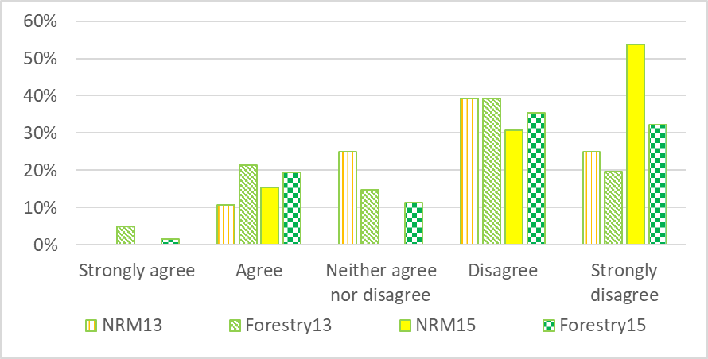

Figure 5. Students responses to the statement: ’To be honest, I’m simply too lazy to study abroad as an exchange student’.

Despite the competition inside and between the universities to attract foreign students, either for full time study or for part time exchange studies, at least in forestry related activities, from most students’ point of view, internationalization is not needed. Based on practical experience of Estonian forestry related students, only few students have been exchange students. Estonian forestry students’ opinion survey also shows relatively small interest in part-time exchange studies. We can only assume that one reason for little interest could be the essence of forestry, as silvicultural practices are in a fair amount related to local conditions (climate, soil, natural tree species, etc.), thus exchange studies would not be so helpful for future practical work within the domestic forest sector. At the beginning of studies, the majority of young forestry related students are not thinking about the future academic career, where the international studies are an asset. One of the basic assumptions for the obstacles of exchange studies could be poor skills of foreign languages (mainly English), but only 24% of students agreed with it. Nowadays the financial issue seems to be one of the main obstacles for exchange studies; however, within the survey we did not investigate the students’ knowledge about the availability of different scholarships or support programmes.

**References**

Tullus, H. and Reisner, V., 2015: The development of the forest sciences education in Estonia. Pp. 109-114 in Schmidt, P. and Lewark, S. From teaching to learning – when will we take it seriously in forest science education? SILVA Network Publications, 11.

**THE JOINT IUFRO-IFSA TASK FORCE ON FOREST EDUCATION**

**MIKA REKOLA, MAGDALENA LACKNER, JANICE BURNS AND**

**SANDRA RODRÍGUEZ-PINEROS**

**Abstract**

The International Union of Forest Research Organizations (IUFRO) and the International Forestry Students’ Association (IFSA) are running 2015-2017 a Joint IUFRO-IFSA Task Force (JTF) on Forest Education. The aim of the JTF is not only strengthening the education on forests and practices, but also highlighting ways to make the sector attractive for young people. The aims of JTF is to bring together students, educators and other stakeholders to encourage international discussions on forest education and to identify the gaps and challenges in the educational sector. It also aims to enhance forestry students’ mobility and education opportunities.

Keywords: forest education, IUFRO, IFSA

**Introduction**

Recent changes in the forest-based sector, combined with evolving demands from society, have led to new trends in forest education. Changes in forest products’ demand is a starting point for new forest educational needs. The traditional use of forest resources has to be renewed, as there are increasing demands for several environmental services such as for forest recreation, packaging and tissue paper (Szabo *et al*., 2009), and new bio-economy products (Hetemäki and Mery, 2010; Katila *et al*., 2014; Nikolakis and Innes, 2014). Those – mostly global – developments are reflected in the labour market as well as in the expectations of students for a greater diversity of experiences and skills.

Programmes educating about forests and wood as a resource are inherently changed towards multidisciplinary programmes (Sample *et al*. 1999; 2015). In addition, institutional environments for research and education have changed. The drivers of change, mentioned above, provide also new opportunities for the forestry sector.

Forest education has been insufficiently addressed in existing global efforts so far, for instance, the Food and Agricultural Organization (FAO) has no active programme on forest education. However, there exist actively functioning regional forest education networks such as Silva Network in Europe, the National Association of University Forest Resources Programmes (NAUFRP) in USA, or the Asia-Pacific Forestry Education Coordination Mechanism (AP-FECM).

The collaborative effort between the International Union of Forest Research Organizations (IUFRO) and the International Forestry Students’ Association (IFSA) is not only strengthening the education on forests and practices, but also highlights ways to make the sector more attractive for young people again. The Joint IUFRO-IFSA Task Force (JTF) on Forest Education, established in 2015, is a unique project, bringing together the different perspectives of the educational environment (see http://www.iufro.org/science/task-forces/forest-education/). IUFRO Task Forces are established on a temporary basis during each 5-year IUFRO Board term to advance interdisciplinary cooperation in forest research fields that span two or more IUFRO Divisions. The focus is on emerging key issues that are of great interest to policy makers and groups inside and outside the forest sector, and contribute to international processes and activities (see http://www.iufro.org/science/task-forces/).

Within the JTF non-governmental organizations, researchers and students are working together to shape the future of forest education. The focus of the JTF is on education for forest professionals mainly with university level degree whereas education for forest workers and forest owners are not tackled. The aims of JTF are to bring together perspectives and knowledge of students, educators and other stakeholders, to encourage international discussions on forest education and capacity building, to identify, compile and communicate the gaps and challenges in forest education, especially highlighting the new fields of forest education, and to enhance forestry students’ mobility and education opportunities.

The work of the JTF is divided in four working packages (WP): 1) Global Outlook on forest education (GOFE), 2) Higher forest education interactive tool, 3) Trainings for forestry students, and 4) Encouragement of students' involvement in IUFRO events and counterbalance of extracurricular students’ activities.

**Implemented activities of the Task Force on Forest Education**

*Global Outlook on Forest Education (GOFE)*

The objective of GOFE is to produce a science-based report on forest education issues related to higher education. More specifically the objectives are:

* To analyse the effects of forest curricula and teachers’ knowledge on learning outcomes.
* A specific research question is whether or not learning outcomes from forest science (FS) centred curricula are different from curricula focusing on Natural Resources (NR).
* To make a comprehensive competencies gap analysis on an international scale using up-to-date scientific methods.
* To analyse the possibilities of new learning methods and approaches, for example those related to e-learning and life-long-lerning (LLL).

The version of the Integrative Pedagogic (IP) model (Tynjälä *et al*., 2014) is applied as a frame of reference for GOFE. The IP model was previously adopted to study technology-enhanced learning in workplace competence development, modern e-learning methods, knowledge building and networked expertise (Hakkarainen *et al*., 2004), simulations, virtual worlds and game like solutions (Krange *et al*., 2012). Learning outcomes are analysed using the concept of competency. Hooghiemstra (1992) defined a competency as an underlying characteristic of an individual, which is causally related to effective or superior performance in a job. It is useful to separate two categories of competences: first, differentiating competencies which separate low and high level performers, and second, threshold or essential competencies which indicate minimum or average requirements for performers (Campion *et al*., 2011).

Gap analysis can be seen as a large framework covering the comparisons of competences produced by education and working life needs. Gap analyses have been executed within forest education already for nearly 50 years. One of the major findings, especially from the US, has been the fact that there is a need to have more training for generic competences such as communication, ethics, teamwork and leadership (Barret, 1953; Miller and Lewis, 1999; Sample *et al*., 1999; 2015). Similar results have also been obtained from Europe (Schuck, 2009) and South America (Arevalo *et al*., 2010).

The Behavioural Event Interview (BEI) methodology was developed by McClelland (1973) and is used in GOFE. The underlying notion with BEI is that it is easier for people to recognize those working men who are competent than what makes them competent (McClelland, 1973; 1998). As an analogy one might say this equates to determining how good a motor boat is. Engineers may compare the performance of each element of the boat and arrive at a somewhat objective measure. Yet the customer can more easily arrive at the same conclusion by driving a boat. Similarly, competence can be measured as a technical construct, but the BEI methodology aims at first recognising high performance and only afterwards determining which factors cause such an appraisal.

Empirical data collected and analysed mainly by IFSA students worldwide in more than 15 countries and a comprehensive gap analysis will help to recommend future possibilities of learning methods and approaches.

*New Database: Forestry Education at Your Fingertips*

The WP2 is related to information dissemination of forest education opportunities. A major product of the Joint IUFRO-IFSA Task Force on Forest Education, a forestry education database (gfis.net/gfis/education/) was produced in partnership with the Global Forest Information Service (GFIS). The database is intended to enhance forestry students' mobility and to promote forestry education activities online. A beta version, published in October 2016, provides quick access to over 900 forestry-related university programmes (BSc, MSc, and PhD) at more than 400 institutions worldwide (Forest education database, 2015.)

In 2017, the database will evolve into an interactive tool connecting users with continuously updated education-related content including: news, research blogs, online. In the future, it will disseminate information about courses and webinars, scholarship and mobility opportunities, research contracts, internships, open-access publications, theses, and more.

*Student trainings*

The increasing demand for benefits and services of forest ecosystems require new knowledge and competencies of future forest professionals. Although there have been changes in forest curricula around the world, gaps are still existing and need to be filled (e.g., Sample *et al*., 1999; 2015). At the same time, there is a lot of potential for organising student trainings related to IUFRO scientific meetings and conferences. These events bring together teachers as scientists and students, often as volunteer organisers. In this WP3 a template for IUFRO student trainings is prepared and tested in pilot actions.

The pilot trainings follow a pre-designed framework and format including up-to-date innovative and modern teaching methods and techniques.

The core team of the Joint Task Force developed a pilot action during the IUFRO congress “X Congreso Latinoamericano de Derecho Forestal Ambiental: “Bosques Gente y Paz, Una Oportunidad para la Integración Latinoamericana“ in Bogota, Colombia in November 2016. The topic “Forest Governance” was a timely response to the raising demand for students to understand the complex topic of international forest policy processes.

*Encouragement of students' involvement in IUFRO events*

The objective of the WP4 is to promote and systematize students’ involvement during gatherings of forest experts and professionals. Our goal is to advocate for counterbalancing the effort and engagement of students in international processes and events with university credits. Therefore, a concept for evaluation and guidelines for involving students in the various meetings of IUFRO units are defined. Good experiences have been made during IUFRO meetings in the last years. However, there is still a need that institutions increase substantially their efforts for financially supporting engaged students.

**Conclusions**

Forest-based sector and forest education are both under structural changes globally. The traditional use of forest resources is under renewing processes which reflect in the labour market as well as in the expectations of future graduates. At the same time, forest education which has been modified towards multidisciplinary programmes, and new information technology will provide challenges and opportunities for higher education. In this evolving environment, the Joint IUFRO-IFSA Task Force (JTF) on Forest Education is an effective and timely project taking place 2015-2017.

JTF has a diverse set of objectives to enhance forest education globally. It has organised itself into four working packages to enhance efficiency. JTF is now contributing to scientific research on forest education, is providing information for students about educational opportunities, and develops special training and involvement systems for students and young professionals. There are therefore good first results showing the relevance of research-student organisations collaborations.

**References**

Arevalo, J., Pitkänen, S., Gritten, D. and Tahvanainen, L., 2010: Market-relevant competencies for professional foresters in European graduate education. International Forestry Review, 12, 200-208.

Barrett, J.W., 1953: The role of humanities and other liberal courses in the professional forestry curriculum. Journal of Forestry, 51, 574–578.

Campion, M. A., Fink, A. A., Ruggeberg, B. J., Carr, L., Phillips, G. M. and Odman, R. B., 2011: Doing competencies well: Best practices in competency modeling. Personnel Psychology, 64, 225-262

Cheng, B., Wang, M., Mørch, A., Chen, N.-S., Kinshuk, K. and Spector, J. M., 2014: Research on e-learning in the workplace 2000–2012: a bibliometric analysis of the literature. Educational Research Review, 11, 56–72.

Forest education database. 2015. gfis.net/gfis/education/. visited Dec 30 2016

IUFRO taskforces.<http://www.iufro.org/science/task-forces/>, visited Dec 30, 2016

Joint IUFRO-IFSA Task Force (JTF) on Forest Education. 2015.<http://www.iufro.org/science/task-forces/forest-education/>. visited Dec 30, 2016

Hakkarainen, K., Palonen, T., Paavola, S. and Lehtinen, E., 2004: Communities of networked expertise: Professional and educational perspectives. Amsterdam: Elsevier.

Hetemäki, L. and Mery, G., 2010: Implications of Technological Development to Forestry.Pp. 157- 181, in Mery, G., Katila, P., Galloway, G., Alfaro, R.I., Kanninen, M., Lobovikov, M. & Varjo, J. (eds.): Forests and Society – Responding to Global Drivers of Change. IUFRO World Series Volume 25. Vienna.

Hooghiemstra, T., 1992: Integrated Management of Human Resources. Pp. 17-46 in Mitrani, A. & Dalziel, M., and Fitt, D: Competency Based Human Resource Management. London

Katila, P., Galloway, G., de Jong, W., Pacheco, P. and Mery, G. (eds.), 2014: Forests under pressures - local responses to global issues. IUFRO World Series Volume 32, Vienna.

Krange, I., Moen, A. and Ludvigsen, S., 2012: Computer-based 3D simulation: a study of communication practices in trauma team performing patient examination and diagnostic work. Instructional Science, 40, 829–847.

McClelland, D.C. 1973. Testing for competence rather than for “intelligence”. American Psychologist 28, 1-4.

McClelland, D.C., 1998: Identifying competencies with behavioural event interviews. Psychological Science 9, 331–339.

Miller, C. and James G. L. 1999: A contested past: Forestry education in the United States, 1898-1998. Journal of forestry 97, 38-43.

Nikolakis, W. and Innes, J. (eds.), 2014: Forests and Globalization: Challenges and Opportunities for Sustainable Development. Routledge.

Sample, V. A., Ringgold, P. C., Block, N. E., Giltmier, J.W., 1999: Forestry Education: Adapting to the Changing Demands on Professionals. Journal of Forestry, 97, 9, 4-10

Sample, V.A., R.P. Bixler, M.H., MCDonough, S.H., Bullard, and Snieckus, M.M., 2015: The promise and performance of forestry education in the United States: Results of a survey of forestry employers, graduates, and educators. Journal of Forestry 113, 528–537.

Schuck, A., 2009 Perspectives and limitations of Finnish higher forestry education in a unifying Europe. Dissertationes Forestales 78. 124 p. Available at<http://www.metla.fi/dissertationes/df78.htm>

Szabó, L., Soria, A., Forsström, J., Keränen J.T. and Hytönen, A., 2009: A world model of the pulp and paper industry: Demand, energy consumption and emission scenarios to 2030, Environmental Science and Policy 12, 257-269,

Tynjälä, P., Häkkinen, P. and Hämäläinen, R., 2014: TEL@work: Toward integration of theory and practice. British Journal of Educational Technology 45, 990–1000

**ESTONIAN FORESTRY STUDENTS’ ASSOCIATION**

**KRISTJAN SEPP**

**History**

It all started in 31st of October 1989 when 23 forestry students gathered to establish the Estonian Forestry Students’ Association. The main reason why the students started the union was the goal to reach out of the Soviet Union and to provide a professional ground for students to give statements in the local forestry sector during those difficult times. The logo of the association is an open pine cone. The official colours chosen are green, blue and black. These colours are also on the flag of the association. Green stands for forest, blue for sky and pure water and black for the soil where the forest’s roots are. This original flag is still in the rooms of the association. In Figure 1 you can see the flag blessing ceremony, which was held by the Estonian healer Vigala-Sass, and the logo of the association.

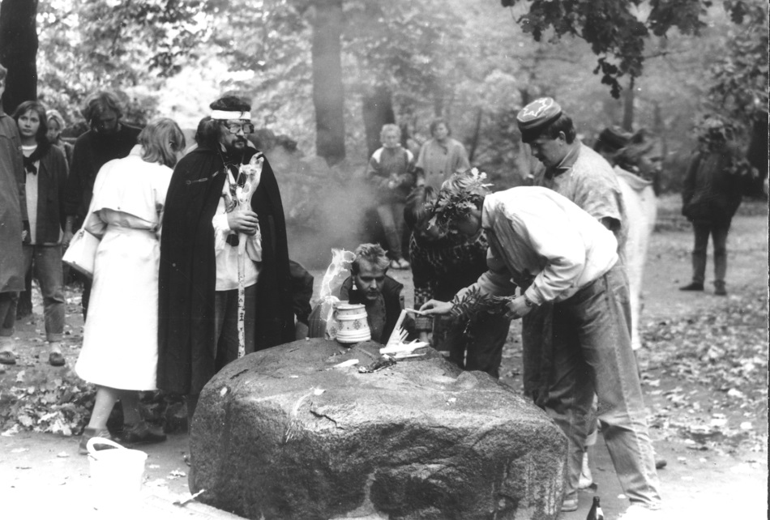

Figure 1: Flag blessing ceremony and the logo of the Estonian Forestry Students’ Association.



**Present**

The Estonian Forestry Students’ Association acts as a link between studying and working. Through us it is easier for our members to find traineeships and jobs in the local market. Members of the association are forestry, natural resource management and wood processing technology students. Currently the number of members has reached 71. Throughout the 27 years a lot of our active members have reached the status of alumni of the association. The number of our alumni is over 250. This means that they form a considerable network in our local sector and are able to provide us with valuable know-how.

In addition to being the middleman between the forestry sector and forestry working life on the one side and the students on the other the output which we offer to our members varies a lot. We organise lectures “Forester Talks”, hunting and game management events, Christmas seminars, hikes, excursions, Summer Games and biennial visits to Joensuu, Finland, where our Finnish friend-association is based. For the lecture-series “Forester Talks” we invite famous Estonian foresters back to school to tell students their own success stories. The lectures take place in a relaxed atmosphere and are really educational and eye-opening. The main event organized by forestry students in Estonia is the summer games - an annual event where all the alumni, students and teachers gather to spend a weekend together in our practical study base at Järvselja where the university owned experimental forests are located. These games were re-established in 2006. The main competitions are the lake run, football, hatchet throw, rope pulling, and volleyball.

The Estonian Forestry Students’ Association is also a member of IFSA (International Forestry Students’ Association). There are a lot of events to attend, such as the International Forestry Students’ Symposium, the Nordic Partnership meeting, Forestry Versatility etc. Throughout the years several of our members have held official positions at IFSA which provides us with international cooperation skills and a global network of contacts.

Forestry students are represented in university boards by members of the student union. The university provides funds to this student union which they are using to finance activities for students. The Estonian Forestry Students’ Association can and regularly did successfully write project proposals and apply for funding to the students union.

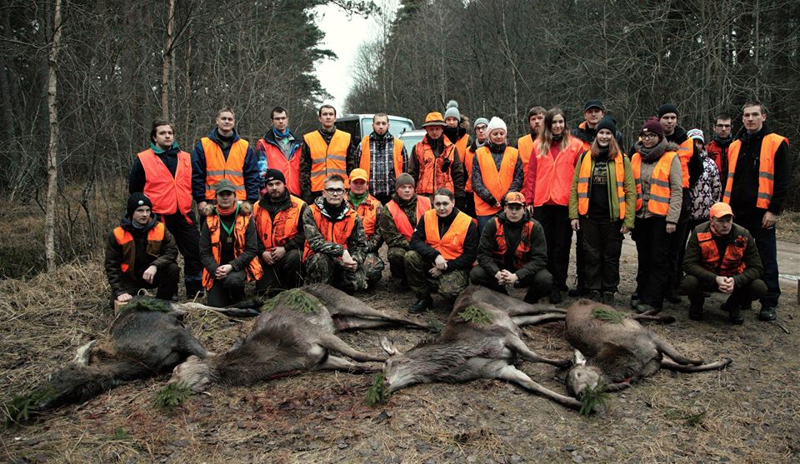

Figure 2: Tableau “After the hunting” and before the party.

**CONCLUDING REMARKS**

**MARTIN ZIESAK**

In order to achieve a reflected view on the symposium topic “Self-study and activation of the learner” a workshop was conducted during this SILVA Network conference. With the purpose to include actively all participants with their individual background, a world café approach was used. The delegates, separated in three groups, developed a shared opinion based on the following three question sets.

* Do we need guided self-study at academic level in forestry education? Side questions; comments: Do we have a consensus here? What is the importance of guided self-study? What are other means of activation of the learner?
  + What are the challenges for successful implementation of good guided self-study? Side questions; comments: Are there structural hindrances? Please consider lectures and students! What are the pro’s and con’s of guided self-study?
* What are possible reactions and suggestions to overcome obstacles in guided self-study? Side questions; comments: Consider structural and procedural aspects. What do you think about learning and teaching traditions and guided self-study?
* What are recommended actions and conclusions? Side questions; comments: Are there recommendations and suggestions, addressing which level?

As the findings of the three separate groups pointed in similar directions, an integration and summarising of results over all three groups is easily possible.

For the first question – do we need guided self-study at academic level in forestry – the consensus was, that guided self-study should not replace any other, existing teaching method. However, it is seen as a useful, additional and complementary element. For a successful implementation of guided self-study many existing challenges should be considered. There is the need to change the mind set of both teachers and students, as they might want to stick to “traditional teaching concepts”. For a successful implementation of guided self-study a framework at the educational institution might be necessary. These challenges are opposed by several good reasons to go for guided self-study . A high flexibility, both for students and teachers, is clear pro, the option to also include generic skills in the educational objectives enriches this didactical tool, and finally the advantage to outsource the intensive tasks of feedback to students as part of guided self-study may help in times of tight resources.

A common suggestion for overcoming these mentioned obstacles is a clear focus on offering instructions and support for teachers, but also to ensure clear instructions and assistance for student-assistants, who have to conduct these guided self-study tasks. In an introduction phase incentives might accompany and foster this procedure.

In the final conclusion for the last question a clear statement is given, to provide more recognition to the teaching task at universities. This is in line with the request for educational courses for staff, involved in teaching tasks. And the very last statement is a clear and positive statement, accepting guided self-study as an additional learning and teaching element.

The final plenary discussion of all attendees compressed the consensus into the “Tartu communique”, which is added in the final section of these proceedings.



**SILVA NETWORK COMMUNIQUE 2016**

**»TARTU COMMUNIQUE«**

In the trend of moving away from ex-cathedra teaching only to a learner-oriented approach, various ways exist to motivate students in their learning effort. One aspect is the strengthening of self-study approaches. This learning-vehicle is classically subdivided into three segments, which are guided self-study, individual self-study and free self-study. It is also important to consider both aspects of knowledge elements, which are subject related but also generic competences.

The SILVA Network meeting 2016 was discussing these questions and has a common understanding in the following aspects:

* A constructive alignment principle should be followed (Biggs, 1996)[7]; that is, the aims of teaching and learning, the learning materials and the evaluation methods should all be coherent.
* We should be open for guided self-study as an additional learning and teaching element.
* For a successful implementation of guided self-study accompanying education for teachers is recommended.
* Students should be prepared for active participation in the learning process, including guided self-study. Guided self-study and other activating methods should be used from the very beginning of studies, that is, from the first semester of BSc.
* Higher education institutions need to formally recognise teaching as an equally important academic activity as research. Evaluation of teaching efforts is crucial, which thus necessitates student feedback.
* Courses on pedagogical basics should be part of PhD candidates’ education programme.

**PARTICIPANTS**

Dohrenbusch, Achim [adohren@gwdg.de](mailto:adohren@gwdg.de)

Faculty of Forest Sciences and Forest Ecology, University Göttingen

Büsgenweg 5, 37077 Göttingen, Germany

Kaimre, Paavo paavo.kaimre@emu.ee

Inst. Forestry and Rural Engineering,

Estonian University of Life Sciences

Kreutzwaldi 56, Tartu, 51014 Estonia

Kostyukevich, Vadim vadim9595@yandex.ru

Petrozavodsk State University

Institute for Woodworking Industries

Nevsky str 58. Petrozavodsk, Russian Federation

Pirotti, Francesco [Francesco.pirotti@unipd.it](mailto:Francesco.pirotti@unipd.it)

TESAF Department, University of Padua

Via T. Albinoni 27, 35020 Polverara (PD), Italy

Pohlschneider, Sarah [sarah.pohlschneider.ic@uhi.ac.uk](mailto:sarah.pohlschneider.ic@uhi.ac.uk)

University of the Highlands and Islands, Inverness College,

1 Inverness Campus, Inverness IV2 5NA

United Kingdom

Reisner, Vaike vaike.reisner@emu.ee

Inst. Forestry and Rural Engineering,

Estonian University of Life Sciences

Kreutzwaldi 56, Tartu, 51014 Estonia

Rekola, Mika [mika.rekola@helsinki.fi](mailto:mika.rekola@helsinki.fi)

Department of Forest Sciences, P. O. Box 27 (Latokartanonkaari 7),

00014 University of Helsinki, Finland

Remeš, Jiři [remes@fld.czu.cz](mailto:remes@fld.czu.cz)

Faculty of Forestry and Wood Sciences,

Prague University of Life Sciences

Kamycka 961/129, 165 00 Prague, Czech Republic

Schmidt, Pieter [pieterschmidt102a@gmail.com](mailto:pieterschmidt102a@gmail.com)

Utrechtseweg 102a, 6871 DT Renkum, The Netherlands

Santiveri, Francesca santiveri@pvcf.udl.cat

University of Lleida

Rovia Roure 191, 25198 Lleida, Spain

Täll, Kristjan Kristjan.tall@student.emu.ee

Inst. Forestry and Rural Engineering,

Estonian University of Life Sciences

Kreutzwaldi 56, Tartu, 51014 Estonia

Sepp, Kristjan Kristjan.sepp@student.emu.ee

Inst. Forestry and Rural Engineering,

Estonian University of Life Sciences

Kreutzwaldi 56, Tartu, 51014 Estonia

Teder, Meelis meelis.teder@[emu.ee](mailto:Kristjan.tall@student.emu.es)

Inst. Forestry and Rural Engineering,

Estonian University of Life Sciences

Kreutzwaldi 56, Tartu, 51014 Estonia

Tullus, Hardi hardi.tullus@emu.ee

Inst. Forestry and Rural Engineering,

Estonian University of Life Sciences

Kreutzwaldi 56, Tartu, 51014 Estonia

Van Hulten, Neeltje neeltje.vanhulten@wur.nl

Wageningen University,

PO BOX 47, 6700 AA Wageningen, The Netherlands

Vodde, Floor floortje.vodde@emu.ee

Inst. Forestry and Rural Engineering,

Estonian University of Life Sciences

Kreutzwaldi 56, Tartu, 51014 Estonia

Weber, Norbert nweber@forst.tu-dresden.de

Chair of Forest Policy and Forest Resource Economics

Technische Universität Dresden,

Piennerstrasse 8, 01737 Tharandt, Germany

Ziesak, Martin martin.[ziesak@bfh.ch](mailto:ziesak@bfh.ch)

Hochschule für Agrar-, Forst- und

Lebensmittelwissenschaften,

Länggasse 85, CH-3052 Zollikofen, Switzerland

**NON PARTICIPATING AUTHORS**

Burns, Janice burns@iufro.org

International Forestry Students’ Association (IFSA) &

International Union of Forest Research Organizations (IUFRO),

Marxergasse 2, A-1030 Vienna, Austria

Cossati, Alice [cosatti.ifsa@gmail.com](mailto:cosatti.ifsa@gmail.com)

University of Natural Resources and Life Sciences,

Gregor-Mendel-Straße 33, 1180 Wien, Austria

De Lima, Philomena [Philomena.deLima.ic@uhi.ac.uk](mailto:Philomena.deLima.ic@uhi.ac.uk)

University of the Highlands and Islands, Inverness College,

1 Inverness Campus, Inverness IV2 5NA

United Kingdom

Lackner, Magdalena , lena.ifsa@gmail.com

International Forestry Students’ Association (IFSA),

Tennenbacher Straße, 4. 79106 Freiburg im Breisgau, Germany

Mapeto, Tatenda [tatenda.ifsa@gmail.com](mailto:tatenda.ifsa@gmail.com)

Nelson Mandela Metropolitan University, School of

Natural Resources Management, George Campus,

P Bag X6531 Saasveld 6530 George, South Africa,

Rodríguez-Pineros, Sandra sandra_osu@yahoo.com

Autonomous University of Chihuahua,

Periférico Francisco R. Almada Km 1,

Chihuahua CP 33820, Mexcico

Rosset, Christian rosset.christian[@bfh.ch](mailto:ziesak@bfh.ch)

Hochschule für Agrar-, Forst- und

Lebensmittelwissenschaften,

Länggasse 85, CH-3052 Zollikofen, Switzerland

PROCEEDINGS OF THE SILVA NETWORK CONFERENCES

See also www.silva-network.eu

|  |  |  |  |  |  |
| --- | --- | --- | --- | --- | --- |
| **Year** | **Location** | | **Title** | **Editors** | **Published in, as** |
| 1997 | Wageningen, Netherlands | | New requirements for university education in forestry | Schmidt, P., Huss, J., Lewark, S., Pettenella, D. & Saastamoinen, O. | 1998,  DEMETER SERIES 1 |
| 1998 | Joensuu, Finland | | Forestry in changing societies in Europe. Information for teaching module. Part I and Part II. | Pelkonen, P., Pitkänen, A., Schmidt, P., Oesten, G., Piussi, P. & Rojas, E. | 1999,  SILVA Network |
| 2002 | Warsaw, Poland | | ITC in higher forestry education in Europe | Tahvanainen, L. & Pelkonen, P. | 2004,  SILVA Network Publications 1 |
| 2003 | Beauvais, France | |
| 2004 | Freising, Germany | | Quality and competence in higher forestry education | Tahvanainen L., Pelkonen, P. & Mola, B. | 2004,  SILVA Network Publications 2 |
| 2005 | Wageningen, Netherlands | | Forestry education between science and practice. | Schmidt, P. &  Bartelink, H.H. | 2006,  SILVA Network Publications 3 |
| 2006 | Valencia, Spain | | Quality assurance and curriculum development in forestry and related sciences. | Schmidt, P., Rojas-Briales, E., Pelkonen, P. & Villa, A. | 2007,  SILVA Network Publications 4 |
| 2007 | Freiburg im  Breisgau, Germany | | Design and functioning of international forestry curricula: considerations and experiences | Schmidt, P. & Lewark, S. | 2008,  SILVA Network Publications 5 |
| **Year** | **Location** | | **Title** | **Editors** | **Published in, as** |
| 2008 | Copenhagen, Denmark | | What do we know about our graduates? Graduate analysis for forest sciences and related curricula | Schmidt, P. Lewark, S. & Strange, N. | 2010,  SILVA Network Publications 6 |
| 2009 | Thessaloniki, Greece | | Development of forest sciences curricula in Europe | Schmidt, P. Lewark, S. & Aravanopoulos, F.A. | 2013  SILVA Network Publications 7 |
| 2010 | Zagreb, Croatia | | Bachelor / master education in forest sciences – Ready for the next decade? | Schmidt, P., Susnjar, M. Müller-Starck, G. & Lewark, S | 2013,  SILVA Network Publications 8 |
| 2011 | Saint Petersburg, Russia | | Bologna cycles 1 to 3 in higher forestry education – Objectives and reality | Schmidt, P., Müller-Starck, G., Chubinsky, A. & Lewark, S. | 2014,  SILVA Network Publications 9 |
| 2012 | Lleida, Spain | | Do students learn what they will need later? About expected learning outcomes and competences of graduates | Schmidt, P., Vega-Garcia, C., Müller-Starck, G. & Lewark, S. | 2014,  SILVA Network Publications 10 |
| 2013 | Istanbul, Turkey | | From teaching to learning – When will we take it seriously in forest sciences education? | Schmidt, P. &  Lewark, S. | 2015,  SILVA Network Publications 11 |
| 2014 | Zollikofen, Switzerland | | Practice orientation in forestry curricula in universities and universities of applied sciences | Schmidt, P., Lewark, S., Müller-Starck, G. & Ziesak, M. | 2016, SILVA Network Publications 12 |
| 2015 | Vienna, Austria | Should all forestry students learn the same?  Generalist or specialist approaches | | Schmidt, P., Hasenauer, H. & Lewark, S. | 2016, SILVA Network Publications 13 |
| 2016 | Tartu, Estonia | Forest science education: Self-study and activation of the learner | | Schmidt, P., Lewark, S. & Reisner, V. | 2017, SILVA Network Publications 14 |

1. Based on Schmidt, 2014.
2. Based on Schmidt, 2015.
3. Based on Schmidt, 2016a
4. Based on Schmidt, 2016b
5. By the time of editing in early 2017 the study reached analysis stage.
6. Pseudonyms have been used to protect participant anonymity.
7. Biggs, J., 1996: Enhancing Teaching through Constructive Alignment. Higher Education 32: 347-364